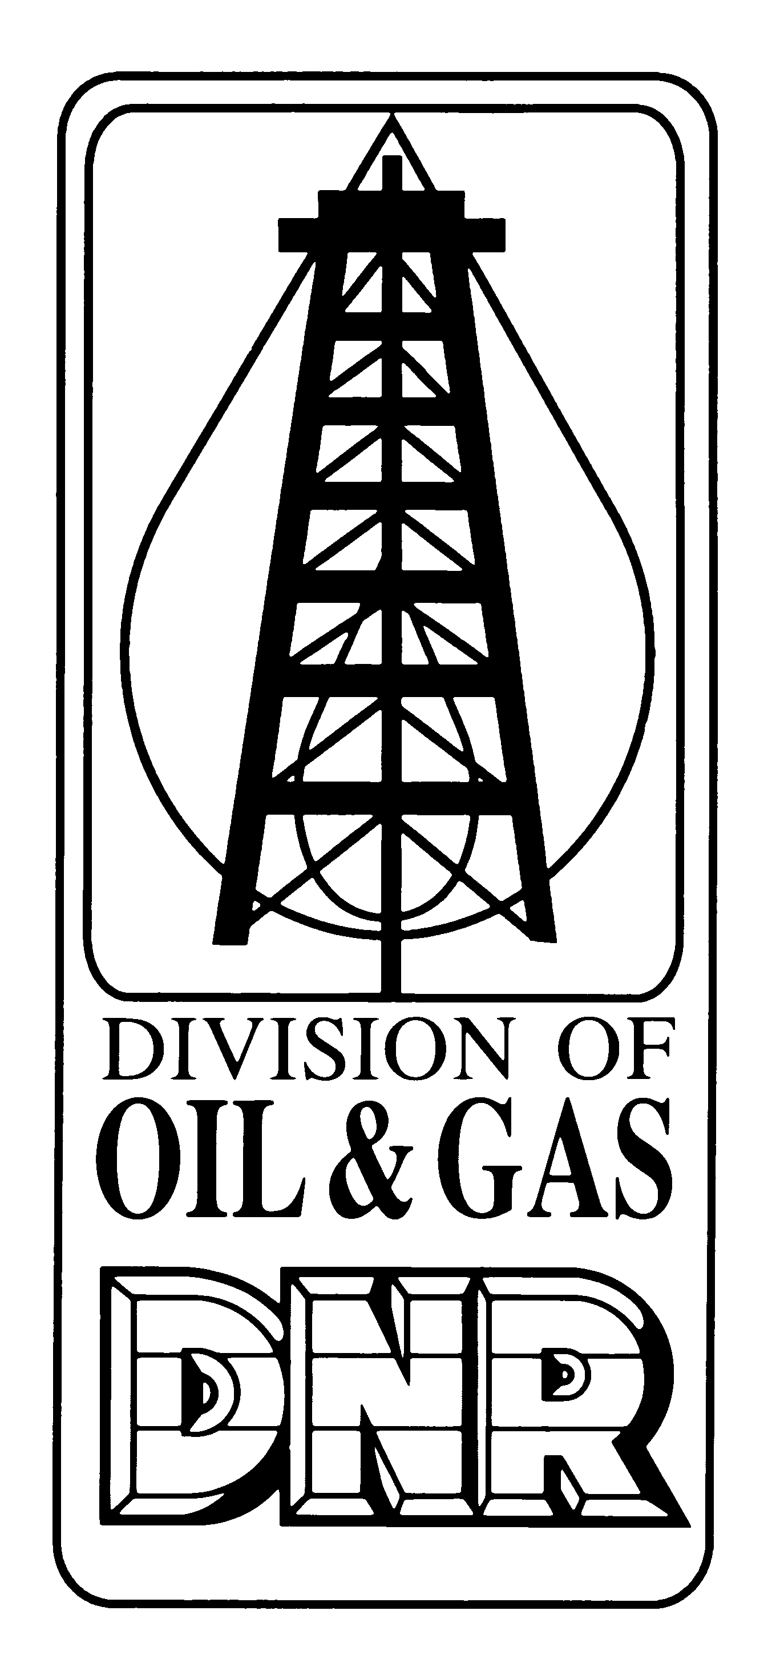 | APPLICATION FOR  ASSUMPTION OF RESPONSIBILITY  Form No. A6  Revised on 7/29/26  INDIANA DEPARTMENT OF NATURAL RESOURCES  Division of Oil and Gas  402 W. Washington St., Rm. 293  Indianapolis, IN 46204  Phone (317) 232-4055  FAX (317) 232-1550  Internet: http://www.state.in.us/dnroil
Permit Number |  | Section | Township |  | Range
Name of lease |  |  |  | Well Number

PART I LANDOWNERS STATEMENT
I certify that I am the owner of land on which a facility regulated under IC 14-37 was located. At my request, the following items were left for my personal use.
Well (As a water well)  @ plugback depth of ft. |  | Excavations |  | Equipment |  | Surface casing
I hereby state that I will not use the well or excavations for oil and gas purposes as defined by IC 14-37 without prior approval from the Division of Oil and Gas.
We affirm under the penalty for perjury that the foregoing is true to the best of our knowledge and belief.
Signature of operator |  |  |  |  | Date signed
Signature of landowner |  |  |  |  | Date signed

PART II DIVISION APPROVAL
Signature of inspector | Date signed

SPECIAL REQUIREMENTS

- This form must accompany the Plugging and Abandonment Report if all of the boxes in the site Certification section of that report are not checked.
- Only those persons whose names appear in PARTS V or VI of the Organizational Report may sign this form as the operator
- The signatures of the operator, landowner, and inspector must appear on this form before the assumption of responsibility will be accepted
- If the landowner is accepting responsibility for a well it must be plugged back to a depth that is no deeper than the bottom of the lowest Underground Source of Drinking Water.

