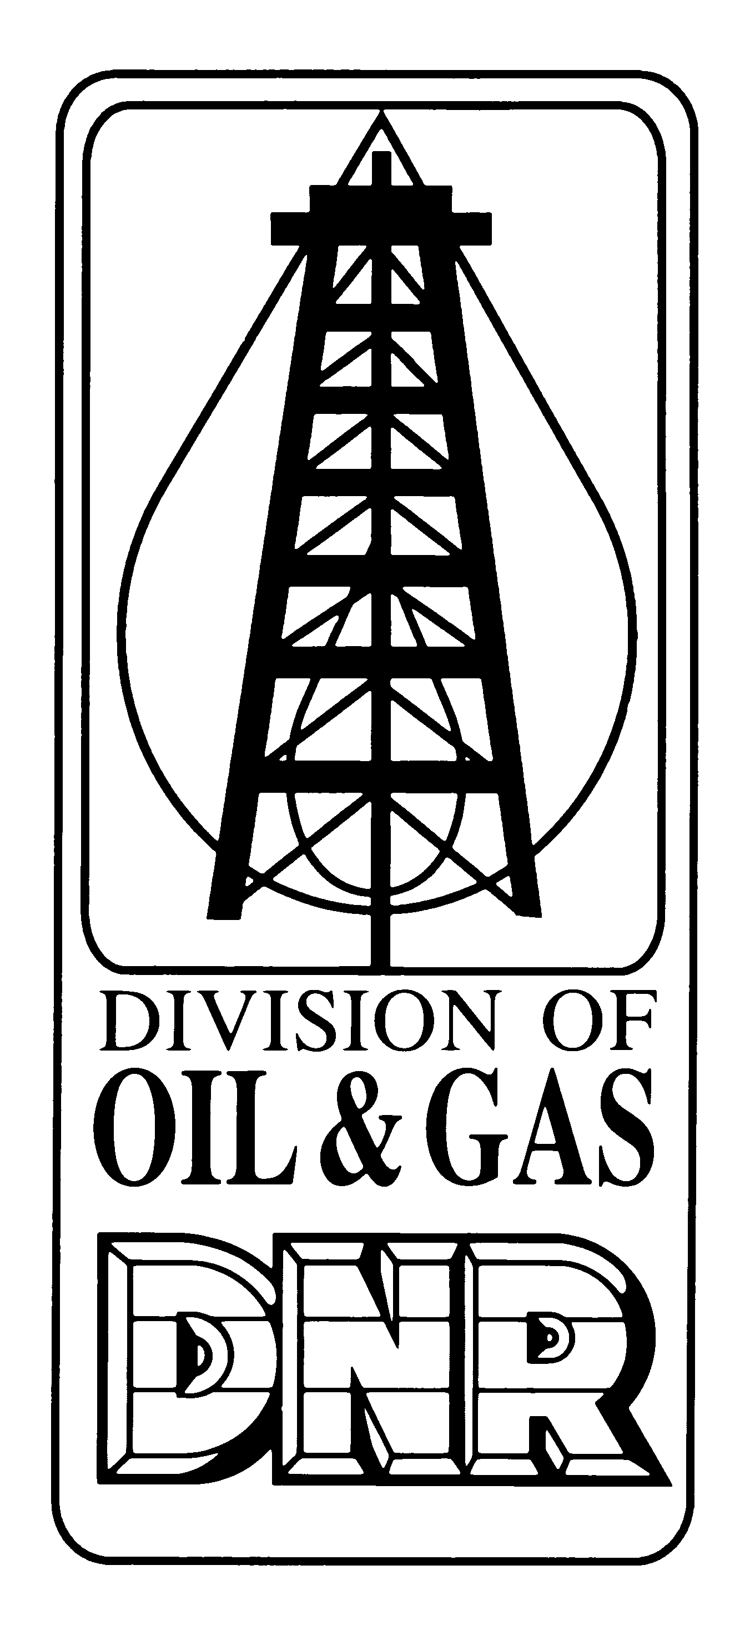 | APPLICATION FOR TEMPORARY  ABANDONMENT or PLUGGING DEFERRAL  Form No. A3  Revised on 3/16/2006  INDIANA DEPARTMENT OF NATURAL RESOURCES  Division of Oil and Gas  402 W. Washington St., Rm. 293  Indianapolis, IN 46204  Phone (317) 232-4055 FAX (317) 232-1550  Internet: http://www.in.gov/dnr/dnroil/ | FOR STATE USE ONLY
 |  | Date received: | Date approved:
 |  | Approved by:
 |  | Valid thru:

PART I GENERAL INFORMATION
Name of Operator: | Telephone number:  ( ) - | Permit number:
Address of Operator:

Type of submission (Check only one) Plugging Deferral until _____________ TA New TA Renewal

PART II WELL AND LEASE INFORMATION
Name of lease: | Well number: | County: | Township: | Range: | Section: | 1/4: | 1/4: | 1/4:
Footage’s: ft. from N, S, NW, SE line
ft. from E, W, NE, SW line
Well Type (Check only one):

Oil Gas Disposal Enhanced Recovery Other, specify:

Date well drilled: |  | Depth of surface casing:  ft.
Is surface casing cemented to surface?: Yes No Unknown If No, number of sacks cement & yield:
Is well equipped with: Long string cemented to surface? Yes No Unknown If No, number of sacks cement & yield:

Intermediate or coal protection string cemented to surface? Yes No Unknown If No, number of sacks cement & yield:
Select all that apply: Well is equipped with Rods and Tubing Tubing and Packer Tubing with no Packer

Packer set at depth No Tubing Bridge plug at depth Other: _______________
Is the well equipped with a wellhead, stuffing-box assembly, or other fittings or valves capable of providing long-term containment of any wellbore fluids? Yes No If No, describe modifications that will be made to ensure that all wellbore fluids will be contained within the well and not released into the environment during the period of Temporary Abandonment: ___________
________________________________________________________________________________________________________
________________________________________________________________________________________________________
Is well currently active?: Yes No If No, date well became inactive: FORMTEXT
Is a copy of the FLUID LEVEL TEST REPORT or the results of the most recent MIT for the well attached with this application?

Yes No NOTE: A completed FLUID LEVEL/PRESSURE TEST REPORT, MIT or other demonstration of well integrity must be submitted before this application can be approved

PART III PURPOSE OF TA REQUEST
The following information is required for all Temporary Abandonment requests: (Attach additional sheets if needed)
Skip to Part IV if requesting Plugging Deferral
- Reason for requesting Temporary Abandonment: ________________________________________________
_____________________________________________________________________________________________________
_____________________________________________________________________________________________________
- Improvements or workovers required (if any): ____________________________________________________
_____________________________________________________________________________________________________
_____________________________________________________________________________________________________
- Time schedule for returning well to production: ___________________________________________________
_____________________________________________________________________________________________________

PART IV AFFIRMATION
I affirm under penalty of perjury that the information provided in this form is true to the best of my knowledge and belief.
Signature of operator or authorized agent | Date signed

FOR DIVISION USE ONLY
Inspection checklist:

Surface sealed Pits filled ID posted Unrelated equipment removed Demonstration made
Recommendation:
Approve as Requested Deny Approve with conditions: _____________________________________
_____________________________________________________________________________________________________

Inspector: Date:

INSTRUCTIONS

PART I GENERAL INFORMATION
- Enter the name of the operator exactly as it appears on the Organizational Report
- If a previously approved TA request has expired, or will be expiring in the near future, select “Renewal”. Otherwise select “New”.

PART II WELL AND LEASE INFORMATION
- Provide all of the information requested to identify the current well condition. This is important to assess the relative risks the well may pose to release production fluids into the environment or to contaminate USDW’s.
- A completed WELL FLUID LEVEL/PRESSURE TEST REPORT or the results of the most recent MIT must be attached to this application or submitted before this application is approved.

PART III PURPOSE OF REQUEST
- A – Provide a detailed explanation of the reason for requesting TA for this well. Typical reasons include a lack of infrastructure development, contractual barriers, time to conduct detailed engineering/geologic evaluations, or the need to perform extensive workover or recompletion operations before operations resume.
- B - A complete description should be provided of all improvements or workovers that will be required, if any, before returning the well to production. The list should be specific and address any improvements needed to oil/water separation equipment, crude oil storage tanks, flow lines, secondary containment, produced water storage vessels, water injection facilities, access roads, and any completion/workover work that will be required during the period of TA.
- C – Provide a timetable for completing the steps identified in B above including dates by which the activities are intended to be completed and the date the well is expected to be returned to active production.

PART IV AFFIRMATION
- The TA request must be signed by the operator or authorized representative to affirm that all of the information provided in this form is true to the best of their knowledge and belief.

NOTE: SUBMIT COMPLETED APPLICATION TO INSPECTOR

