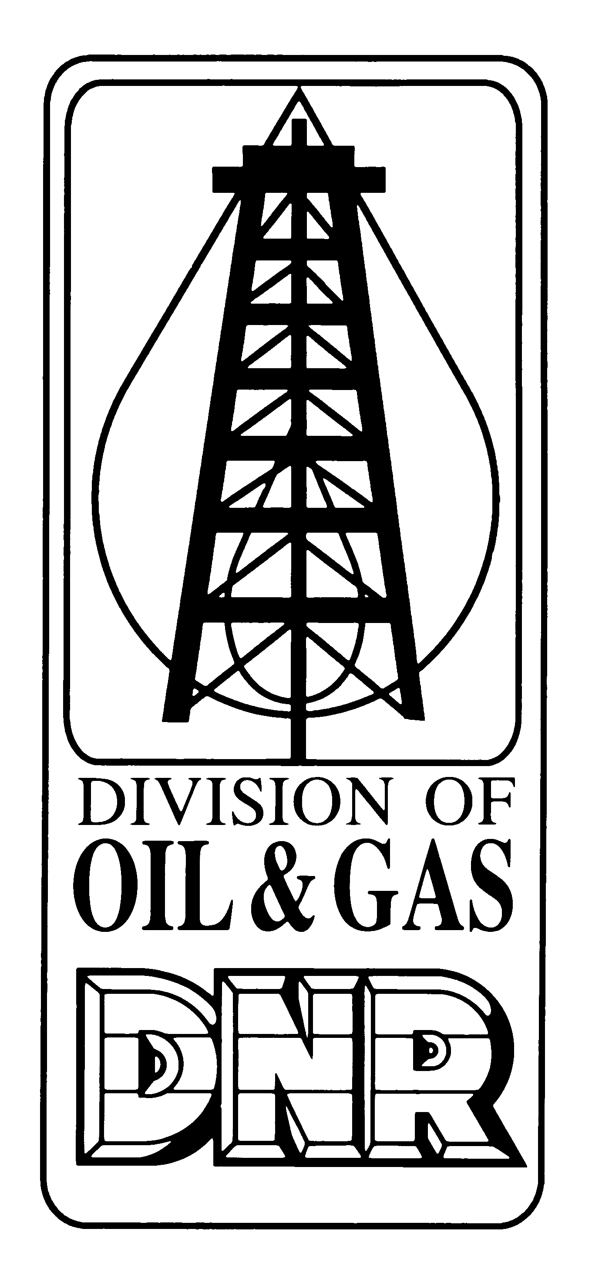 | APPLICATION FOR ALTERNATE  PLUGGING METHOD OR MATERIAL  Form No. A9  Revised on 10/4/2004  INDIANA DEPARTMENT OF NATURAL RESOURCES  Division of Oil and Gas  402 W. Washington St., Rm. 293  Indianapolis, IN 46204  Phone (317) 232-4055  FAX (317) 232-1550  Internet: http://www.in.gov/dnroil
PART I GENERAL INFORMATION
Name of operator |  |  |  |  | Telephone number  ( ) - |  |  |  | Permit number
Address of operator ( Check here if this is a new address )

City |  |  |  |  | State |  |  |  | Zip code
PART II PROPOSED PLUGGING DETAILS
CASING RECORD |  |  | STRING #4 | STRING #3 |  | STRING #2 |  |  |  | STRING #1
Casing/ tubing diameter (O.D.)
Amount set (feet)
Amount left in well (feet)
Hole size (inches)
Cement used to set (cu. ft.)
PLUGGING RECORD |  |  | PLUG #1 | PLUG #2 |  | PLUG #3 |  |  |  | PLUG #4
Hole/ pipe diameter (I.D.)
Material used to plug
Depth to bottom of plug (feet)
Depth to top of plug (feet)
Amount used (cu. ft.)
PART III EXPLANATORY INFORMATION
Section a. Select the reason(s) an alternate plugging method or material is needed. (Check all that apply and explain)
Human health/ safety risk Environmental damage risk Fish/ wildlife/plant damage risk Materials stuck in well
Section b. Detail the efforts made to plug this well in accordance with 312 IAC 16-5-19(b) through (i). (Be specific)
PART IV AFFIRMATION
I affirm under penalty of perjury that the information provided in this application is true to the best of my knowledge and belief.
Signature of operator or authorized agent |  |  |  |  |  |  | Date signed
PARTS V and VI FOR DIVISION USE ONLY
PART V INSPECTOR CERTIFICATION
Recommend approval  Recommend denial |  | Reasons (If denied)
I certify that the applicant has/ has not made a reasonable attempt to plug this well as shown in PART III above
Signature of Inspector |  |  |  |  |  |  |  | Date signed
PART VI DIRECTOR APPROVAL
I approve the plugging of this well in the manner specified above in accordance with the provisions of 312 IAC 16-5-19,
Signature of Division Director |  |  |  |  |  |  |  | Date signed
SPECIAL REQUIREMENTS
- Part IV of this application may only be signed by a person listed in Parts V or VI of the Organizational Report
- Approval of this application does not relieve the applicant from responsibility for future remedial actions on this well as needed to prevent contamination in accordance with IC 14-37
- The approved application must be attached to the Plugging and Abandonment Report submitted to the division and all information on the reports must match
- The top plug MUST be set at least 50 feet below the deepest USDW in all cases

