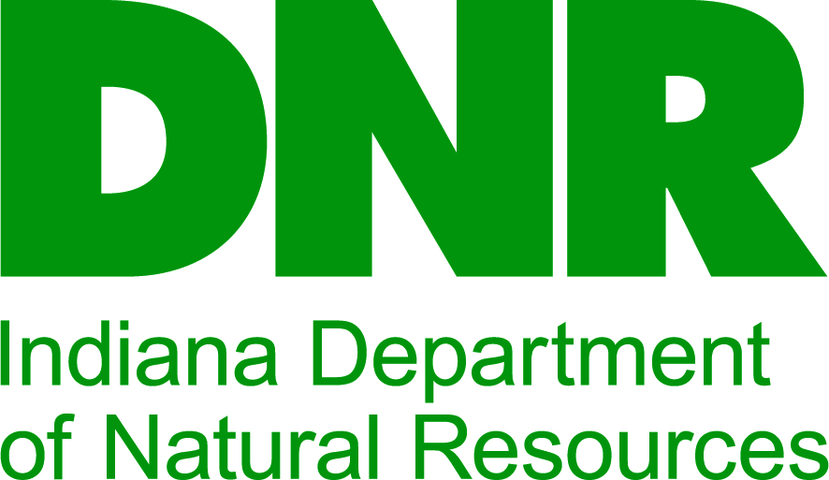

Anytown, Indiana 5-year Park and Recreation Master Plan

2021 to 2026

A Comprehensive Master Plan by the Anytown Park Board and the Anytown Parks and Recreation Department

Anytown Parks and Recreation Department
5555 Anytown Avenue
Anytown, IN 44444
555-555-1212
E-mail: Anytownparks@anytown.in.us
Website: www.anytown.in.us/parks

Table of Contents

Contents
Introduction 4
Definition of the Planning Area 5
Goals of the Plan 5
The Park Board/Department 6
The Park Board 6
The Park Department 7
Facility Inventory 9
Current Programs 10
Budget 10
Table 1: APRD Budget 11
Other Recreation Providers 11
Natural Features and Landscape 12
Topography 12
Geology/Soils 12
Forest and Vegetation Resources 12
Water Resources 13
Man-made, Historical and Cultural 14
Transportation Links 14
Industry in Anytown 15
Anytown Parks Department History 16
Anytown Lake and the Hoosier Canal 16
Cultural Anytown 17
Social and Economic Factors (from the 2020 US Census) 18
Population (2010-2020) 18
Economics in Anytown 18
Housing 19
Education 19
Socio-economic Summary 19
Accessibility and Federal Accessibility Standards 20
Statement of Accessibility for Anytown 20
Current Accessibility 21
Proposed Accessibility 22
Public Participation 23
Public Meetings 23
Mail Survey 24
Focus Groups 25
Final Public Presentation of the Plan 27
Summary/Comparison of Public Input 28
Needs Analysis 28
What is Issue Analysis? 28
Issues from Public Input 28
Issues from Board, Staff and City officers; Plus Benchmarking and SWOT Analysis 28
National Standards 29
What We Need 29
New Facilities Location Map 30
Priorities and Action Schedule 30
Transition into the New Plan 30
Priorities for 2020 to 2025 31
APRD System-wide Action Schedule 32
Appendices 34
Anytown Regional Map 34
SWOT (Strengths, Weaknesses, Opportunities and Threats) Analysis 35
Community Benchmarking: Anytown; Schmoburg; and Other City, IN 37
Accessibility Compliance Sign-Off Sheet 38
Board Resolution Adopting Plan 39
2020 APRD Public Survey 40
Park Use 40
Programs and Activities 40
Participation 41
Park Funding 41
Newspaper notices, articles, sign-in sheets and meeting info 43

Introduction

The Anytown, Indiana Five-Year Parks and Recreation Master Plan is intended as a supplement to the “IDNR Planning Guidelines for Five Year Parks and Recreation Master Plans.” Local-level planners and consultants thought that an example plan would be beneficial when creating a first-time plan, especially for in-house planners. The Anytown plan was created in response to that need. The following document is only one way to write a parks and recreation master plan. So long as your plan provides at least the minimum information, analysis, and strategic thinking requested in the IDNR Planning Guidelines for Parks and Recreation Master Plans, the format, style and presentation of the plan is up to you. We welcome suggestions for changes and additions, and invite your comments. Please send all comments and suggestions to:

Greg Beilfuss
Chief Planner, Outdoor Recreation
IDNR-Outdoor Recreation
402 W. Washington St., Room #W271
Indianapolis, IN 46204-2782
317-232-4071
gbeilfuss@dnr.IN.gov

Definition of the Planning Area
The service area for the City of Anytown does not stop at the city limits, but includes a buffer area of rural land that extends about two miles from the city center. Past public input and user surveys have indicated that Anytown has a significant and important rural user population, even if those users do not contribute directly to the taxes gathered from the city residents to support recreation. The planning area for the Anytown Parks and Recreation Department (APRD) is the same as the service area. Anytown Parks and Recreation remains committed to making our facilities and services available and accessible to anyone, regardless of resident status, ability to pay or physical/mental ability.

Goals of the Plan

After much discussion, the Anytown Park Department staff and the Park Board have agreed on the following goals for the Five-Year Parks and Recreation Plan:
- Gather feedback and input from as diverse a group of Anytown residents as possible, and report it in an accurate manner.
- Use national recreation standards, combined with a careful needs analysis, to create new strategic priorities for parks and recreation in the city.
- Create a plan that is dynamic and provides pertinent, useful information and guidance for the next five years in Anytown.
- Present the plan and gain its acceptance within the Anytown community.
- Submit the master plan to the Indiana Department of Natural Resources Division of Outdoor Recreation, adhering to the required timeframe for a draft, by Jan. 15 and finalized plans by April 15.
- Receive approval from IDNR for eligibility for application for Land and Water Conservation Fund (LWCF) grant programs.
- Use the plan as a springboard to apply for all applicable grants

The Park Board/Department

The Park Board
The Park Board was first created in 1972, and was re-established in 1987 according to the requirements of Indiana Code 36-10-3. Anytown has a four-member board that serves staggered four-year terms. The current Anytown Park Board is:

Jane Doe, Board President
1313 Hoosier Lane
Anytown, IN 44444
Term: Jan. 2, 2017 to Jan. 2, 2021
Political party affiliation: This Party

John Roe, Board Secretary
P.O. Box 13
Anytown, IN 44444
Term: Jan. 2, 2018 to Jan. 2, 2022
Political party affiliation: That Party

Harold Phipps
818 N. Hoosier Avenue
Anytown, IN 44444
Term: Jan. 2, 2019 to Jan. 2, 2023
Political party affiliation: Party Party

Meredith Venturi
1391 Hoosier Landing
Anytown, IN 44444
Term: Jan. 2, 2020 to Jan. 2, 2024
Political party affiliation: Some Other Party

The Park Department
Park Office
The main office for the parks department is in the City Hall Annex, located at 5555 Anytown Ave., Anytown. The phone is: (555) 555-1212.
E-mail: Anytownparks@anytown.in.us Website: www.anytown.in.us/parks

Mission
- The Mission of the Anytown Parks and Recreation Department is: “To provide a superior recreation and park experience to all members of the Anytown community, creating a better quality of life, access to the outdoors and opportunity for play of all kinds for all ages and abilities.”

Park Board’s Departmental Vision and Goals for the Next Five Years
- The Anytown Parks and Recreation Department will offer a level of service appropriate to the size and growth of the community.
- The Department will provide new opportunities for exercise, fitness and wellness for the community at large.
- The Department should act as a central part of daily quality of life in the community, providing a city identity and a focus for the people of Anytown.

Staff
Park Superintendent: Pat Schmo.
Hired: May 15, 1997.

Recreation Director/Volunteer Coordinator: Chris What.
Hired: Dec. 1, 2000.

Maintenance Supervisor: Terry Who.
Hired: Feb. 14, 1998.

The Anytown Parks and Recreation Department also employs one full-time park staff person, two part-time maintenance staff, and approximately five seasonal employees each year.

Volunteers
In these times of shrinking budgets, rising costs of energy, operations and maintenance, and increasing recreation demand, volunteers from Anytown and the surrounding areas provide us with incredibly valuable assistance. These amazing volunteers are leading programs, coaching and officiating youth sports, assisting us in maintaining and improving the parks themselves and much more. Without our dedicated volunteers we would not be able to provide the quality of parks and programs that we currently enjoy. Our current pool of volunteers varies between 200 and 300 people from all walks of life and every level of the social strata. The APRD can always use more help, and no matter what your skills, interests, or abilities are, we can find fun ways to put them to use in Anytown’s parks. The Department invites all interested persons to participate in our parks volunteer system; please contact Chris What, volunteer coordinator, at 555-1212 for more information.

Friends of the Anytown Parks
The Anytown Parks and Recreation Department has benefited tremendously from the creation of the “Friends of Anytown Parks” group in 1994, and their “Anytown Park Fund” under the Anytown Community Foundation. Many of our volunteers come to us through the assistance of our Friends group, and the financial assistance we receive from the Park Fund has allowed us to maintain current staffing and program levels in spite of significant budget cuts. The current chair of the Friends of Anytown Parks is Janice Peters. She may be reached through the Parks Department at 555-1212, ext. 13. Donations, memorials, contributions, or bequests to the Anytown Park Fund may be made through the Anytown Community Foundation at 1225 Anytown Ave., Anytown; phone: 555-2121.

Facility Inventory
Anytown has an inventory of eight parks ranging from 1 to 25 acres (approximately 48 acres total park land). The Anytown Park system is relatively old, with the newest property having been donated in 1975, and the oldest/largest, Anytown Park, donated in 1955. The age of the parks and much of their equipment creates special problems for accessibility, maintenance and development. In many cases, due to limited funds and staffing, features of the parks are in dire need of updating, replacement or renovation. The following is a brief synopsis of the eight Anytown parks:

- Anytown Park (located at 100 Anytown Avenue; 25 Acres) : Donated to the city by Adolphus Rummel in 1955; 25 acres, including Anytown Lake (5 acres), and a branch of Anytown Creek; features include Rummel House (6 bedroom historic home), a 12 year-old wooden playground structure (does not meet CPSC playground safety or ADA accessibility standards), a paved walking trail around the perimeter of the site, one soccer/football field with small bleachers, two baseball/softball fields, benches, several picnic sites, and one 12’ x 20’ open picnic shelter with tables and a permanent grill.
- North (150 Schmo St.; 5 Acres), South (979 Anytown Avenue; 5 Acres), East (650 Maple St.; 5 Acres) and West (500 Oak Ave.; 5 Acres) Neighborhood Parks: Purchased or donated between 1962 and 1970; these neighborhood parks average 5 acres; each features a small playground with climbing structure, benches, shade trees and sidewalk access.
- Northeast (901 Schmo St.; 1 Acre), Southeast (801 Pine St.; 1 Acre), and Southwest (1001 Oak Ave.; 1 Acre) Mini-Parks: Purchased or donated between 1958 and 1975; these mini parks are each roughly one acre; each mini park features open space, some shade trees and sidewalk access. The newest mini-park is Southwest (donated in 1975), which is in a low-lying area approximately two blocks from the Anytown Consolidated School District complex.

Current Programs
Anytown offers a diverse array of programs that attract many different kinds of users. Anytown has responded to the needs of our community by providing traditional programs, like youth and adult sports leagues, as well as non-traditional activities at the request of users. Some of these non-traditional programs include a volunteer-taught Tai Chi Chuan class, and Raku pottery classes co-sponsored by the Anytown Arts Cooperative. The following is a snapshot of some of the recreation classes and activities that have been offered by APRD staff, volunteers or with our partners:
- Boys and girls Little League baseball (in cooperation with Little League of Anytown).
- Pop Warner football (volunteer coached and officiated).
- Boys, girls and teen soccer (uses Anytown School District facilities).
- Red Cross swimming lessons; senior and adult water aerobics (uses the new Hoosier County hospital indoor therapeutic pool facilities).
- Summer recreation day-camps (in cooperation with the Anytown School District).
- Ice skating on Anytown Lake in winter (ice conditions permitting).
- Tai Chi Chuan exercise classes (taught by volunteers).
- Raku pottery, sculpture and painting classes for both youth and adult (co-sponsored by the Anytown Arts Cooperative).
- “Summerfest” ice cream social and art festival, followed by fireworks, on July 4 of each year (co-sponsored by the Hoosier County Convention and Visitor’s Bureau, and the Anytown Chamber of Commerce).
- “Tulip Tree Days” special event each September.

Economic affordability – Sliding scales based on household income for fees are in place and operating.

Budget
The APRD has experienced several significant budget cuts from the City in recent years, and anticipates that this may be a continuing trend. This has a direct negative effect on several aspects of our operations and maintenance, including the number of staff hired, level of maintenance performed, replacement of vital equipment, and amount of new programming created. The following table shows the past three years of budget for APRD by three main categories: operations and programming, maintenance, and capital projects.

Year | Operations and  Programming | Maintenance | Capital Projects
2018 | $137,000 | $55,000 | Unfunded
2019 | $125,000 | $50,000 | Unfunded
2020 | $115,000 | $45,000 | Unfunded
2021  (Projected) | $102,000 | $40,000 | Unfunded

Table 1: APRD Budget

Other Recreation Providers
The following is a partial list of other recreation providers in the City of Anytown:
- Hoosier County Hospital —Therapeutic pool; some open public hours.
- Anytown School District — Playgrounds available to public while school not in session; some programs offered in cooperation with the APRD. Anytown Parks recently completed a Joint Use Agreement with the Anytown School District to share facilities, staff, programs, and maintenance at some sites. Both sides are benefitting with cost savings, more efficient use of staff and better program access.
- Anytown Church — Small play area on site open to public use while church not in session; some recreation programs offered during summer months open to public.
- Anytown Arts Cooperative — some arts and crafts classes offered; some for free through partnership with the APRD.

Natural Features and Landscape

Topography
The topography of Anytown is fairly flat with only a small hilly area in the northwest corner of the city. There are some low-lying areas that border Anytown Creek, and the creek itself provides the primary drainage for the city as it passes through the city from northeast to southwest to the Hoosier River south of town. The moderately varied topography of Anytown lends itself very well to most kinds of outdoor recreation, especially those that require flat play surfaces; however, there are a few hills on public property that would be sufficient for good sledding/tobogganing in winter.

Geology/Soils
The geology of Anytown is based on a Karst limestone bedrock structure, deep and fertile A and B horizons, and a moderate clay composition. The soils in the city vary somewhat from sandy clay loams in the hillier northwest to silty clay loams in the bottoms near Anytown Creek. The soils in Anytown do not pose significant problems to construction or development, but care should be taken to prevent large-scale building development of the mesic soils in the flood-prone areas surrounding Anytown Creek.

Forest and Vegetation Resources
Anytown enjoys the presence of mature red and white oaks, red maples and tulip trees that were planted as part of a citywide effort in the 1910s and 1920s. They are now aging but magnificent shade trees, especially in the neighborhoods surrounding downtown, Anytown Park, and in the strip bordering Anytown Creek. It would benefit the Anytown Parks to add young native species tree and shrub plantings to many of the smaller parks, especially those where the largest trees may be approaching or past their prime and need removal in the foreseeable future. Emerald ash borer made its first visible appearance in Anytown in mid-2015, and has had a huge impact on the ash trees all over the city, as well as in the parks. Dead or dying trees on public property have been cut down, the stumps ground down, and the wood offered for sale as a fund-raiser for ongoing tree replacement. The cost of EAB to Anytown has been very high, but has finally started to diminish, as the few remaining ash trees succumb to the beetle. Full replacement of those dead ash trees will take time, and more money. Anytown Parks are cooperating with the IDNR Community and Urban Forestry (CUF) program to work on potential solutions to this ongoing problem.
Anytown Parks has also joined the Mid-Indiana Regional Invasive Plant Management Cooperative, in order to share training, resources and labor with other public land managers to attempt eradication of invasive plant species, including Tree of Heaven, Phragmites, Garlic Mustard, Bush Honeysuckle, and Autumn Olive. The Anytown parks are already seeing significant effects from this invasive species removal as forested portions of the parks now have visible native plant understory which used to be choked off with invasive bushes and shrubs. Anytown is also within an area marked for periodic invasive Gypsy Moth treatment under supervision of IDNR Entomology & Plant Pathology and Purdue Extension.

Water Resources
There are only a few surface water resources in Anytown. The city is part of a larger watershed that flows into Anytown Creek. A few small un-named branches, man-made ditches and waterways add to the flow as it passes through the city. The Hoosier River, located near Anytown, only impacts the city during 100-year or greater flood events. The following is a snapshot of surface water in Anytown.
- Anytown Lake — 5 acres; stocked lake with fishing access. The lake is beginning to fill in due to silt flowing in from agricultural areas outside city limits and excess weed/moss growth due to fertilizers from residential lawns and agriculture upstream (eutrophication). Dredging the lake may be a necessity in the next 20 years. Buffer zones have been planted in the upper reaches of Anytown Creek, and have reduced the amount of silt/nutrients reaching the lake; however, the majority of damage is done and eventually will have to be dealt with. Invasive water plant Eurasian Water Milfoil has been discovered in lakes near Anytown, and monitoring of the lake is ongoing.
- Anytown Creek — Several branches in the city; moderately buffered by wooded/brushy areas along much of its length in the city limits, much less buffering occurs in the agricultural lands outside the city limits. Hoosier Riverwatch may begin water quality monitoring soon on the creek as local volunteers have expressed interest in this work.
- Hoosier River — One-half mile outside city limits; has only occasional flooding impact on the city (100-year or greater floods). Anytown and Anytown Creek are part of the greater Hoosier River watershed.

Anytown Creek and Lake do provide water attractions for recreation in Anytown. There is potential for greater use of the stream corridor of Anytown Creek for trails and water access; this should be explored before development in the city makes this physically and financially impossible. Anytown is hoping to apply for an IDNR Recreational Trails Program (RTP) grant in the next several years to facilitate sustainable trail development in the watershed.

Man-made, Historical and Cultural

Transportation Links
Anytown sits astride Indiana State Road 400 (Anytown Avenue), which eventually connects with Interstate 100 approximately 50 miles to the north. Most local traffic uses the country roads and municipal streets for daily travel. There are two railroads that pass within one mile of Anytown; one has a spur that dead-ends in the new Anytown Industrial Park being developed on the east side of town. The Anytown Municipal Airport is a hub for private pilots, local corporations and several small charter services based in Bigcity, approximately 80 miles to the southeast, and Reallybigcity approximately 40 miles to the northwest. Anytown does not have a complete sidewalk system in all portions of the community. Residents who need to travel to APRD facilities are not always able to walk or bike there using city streets without having to cross major highways or SR 400, which has almost no sidewalk access or safe bike/pedestrian crossings. Anytown is beginning to realize that SR 400 now sees significant enough vehicle traffic to be a significant hazard to bicycles and pedestrians trying to access city businesses and amenities on the opposite side of the highway. The City is consulting with INDOT to ascertain options for improved crossings, signage and maybe even pedestrian-initiated crossing signals for several points at major cross-streets coming from residential neighborhoods. Any future RTP grant proposal may work with the INDOT recommendations and attempt to coordinate efforts toward better bike/ped access.

Industry in Anytown
The Anytown Industrial Park was created as an economic development project for the city in the 1980s, when local agriculture and industry were both heavily impacted by the nationwide recession. Development of the industrial park was helped considerably by the addition of a railroad spur into the site. There are now three small factories and assembly plants in the park, and several more are under development. Since several of the factories and plants have hired multiple shifts, there is a growing demand for recreation opportunities in the evenings or at other times of the day outside traditional parks and recreation hours. Anytown’s program staff is working on creation of some experimental programs aimed specifically at these users who may want program access at non-traditional hours. Light industry has taken advantage of the inexpensive labor force, low taxes, and available land in and near the city. The recent recession affected Anytown much as it did the rest of the country, but the loss of several businesses may be offset by expansion of the remaining companies and several new start-ups that show great promise.

Anytown Parks Department History
Anytown started out as a crossroads village near a popular ford over the Hoosier River in the early 1800s. Early settlers stopped here due to the abundant forest for building materials, the nearby river/ford for transportation, the “oak openings” for grazing, and the presence of the clean, clear creek that took the name of the growing community. Anytown has grown slowly but steadily from a village of a few dozen souls to the third-class Indiana city of 18,000+ we know today. Anytown is known historically as an agriculturally-based town, but has taken on more diverse economics in the last 40 years.

The Anytown Parks Department got its start with Adolphus Rummel’s 1955 donation of 25 acres of beautifully landscaped, wooded residential property near downtown. The site included the already 100 year-old Rummel House, and the 5-acre stocked pond that we now call Anytown Lake. The Rummel House and its immediate grounds were listed on the National Register of Historic Places in 1990. Rummel was the multiracial descendant of a former slave, one of the original settlers (his ancestor was a blacksmith, a vital skillset in a newly established pioneer community) of the village that became Anytown. The APRD celebrates its heritage with yearly celebrations, interpretive displays, community projects and cooperation with the Hoosier County Historical Society.

Anytown Lake and the Hoosier Canal
The Hoosier County Historical Society has records that state that Anytown Lake and Anytown Creek were both part of the water supply system for the former Hoosier Canal system that connected with other regional canals and waterways in the 1830s. There are very few visible signs that the canal was here. Much of the former canal and its support system were reclaimed as agricultural/residential lands by new landowners after the canal went bankrupt and was sold, shortly after the Civil War. The former route of the canal can be best seen through aerial photos shot during winter. Several plaques commemorating the canal and its history are placed at sites throughout Hoosier County. Potential exists to partner with the historical society to offer programs and possibly some interpretive signage better illustrating this important city history.

Cultural Anytown
Several significant immigrant populations have relocated to Anytown. There is a large enclave of people who emigrated from Iceland in the mid-1860s, attracted by the oak savannah ecology of the area for grazing sheep and Icelandic ponies. Approximately 10 extended families emigrated here from the areas outside Reykjavik, Iceland, beginning in 1864. There also were a number of families that moved to Anytown in the mid-1980s from Laos and Thailand, and are of Hmong descent. These and other immigrant populations contribute to the very diverse nature of the Anytown community. The cultural diversity of Anytown is reflected in the wide variety of crafts, cuisines and arts that are represented at the city-wide celebrations such as Tulip Tree Days.

Arts
Anytown has always supported a strong artistic community. The City Theatre troupe has offered “summer stock” plays each season since the 1920s. Summer stock refers to an old small town theatre tradition where the troupe puts on well-known shows (chosen from a pool of previous work), each summer season and re-uses stock scenery and costumes each time. Anytown is also known regionally for having a small artist’s colony, which uses venues such as the fall Tulip Tree Days festival and the downtown Anytown Art Gallery to market their creations. The APRD has begun discussions with the City Theatre troupe about creation of an outdoor summer theatre presentation series (possibly even an outdoor Shakespeare Festival), to take place in Anytown Park.

Music
Anytown has a small, all-volunteer City Band that rehearses once per month and performs at the picnic shelter in Anytown Park (as part of a partnership with the APRD) during the summer months, the Fourth of July Summerfest, and Tulip Tree Days. The citywide festivals also showcase the cultural diversity of Anytown with many styles of music being performed by members of the community in celebration of their ethnic and religious traditions.

Festivals
The two big events during the year in Anytown are Summerfest, which takes place each July 4 in Anytown Park and downtown, and Tulip Tree Days, which takes place the second weekend in September of each year. The festivals are increasingly important to the financial health of many non-profit organizations in Anytown as they are able to raise enough funds to be self-sufficient for the following year from the proceeds of fundraiser booths and vending/craft opportunities. The festivals also tie together all the cultural activities of the city. Discussions are under way between the Chamber of Commerce, the Main Street program, the APRD, and the Convention and Visitors Bureau of Hoosier County to create a first-ever Anytown Multi-Cultural Festival, borrowing on similar cultural festivals like the Pierogi Fest in Whiting, and the La Plaza FIESTA celebration in Indianapolis.

Social and Economic Factors (from the 2020 US Census)

Population (2010-2020)
- According to the 2020 US Census, Anytown had 18,542 residents.
  - 49% Male; 51% Female.
  - Median Age: 43.
  - 78% White; 8% Black or African American; 1% American Indian; 6% Asian; 6% Hispanic or Latino; 1% some other race.
  - 20% of population over 5 years of age had a disability.
  - 8% of population speaks a language other than English at home.
- The 2020 Census show a 2.5% population decrease since 2010.

Economics in Anytown
- According to the July 2020 Office of Workforce Development, Anytown had a 4% unemployment rate.
- Median household income in 2020 (dollars): $41,000.
- Families below poverty level: 18%.
- Largest non-agricultural employment area in Anytown: Manufacturing; Second largest: Retail trade.
- Largest Hoosier County employment area: Agriculture.

Housing
- Average household size in Anytown: 2.1.
- 7,901 total housing units.
- 29% of all units are vacant.
- 64% of owners have a mortgage; 36% do not.

Education
- 90% of population high school graduate or higher.
- 15% Bachelor’s degree or higher.

Socio-economic Summary
- Anytown has a higher number of people living in poverty than the national average, but also a higher than average level of education.
- Anytown has a higher level of racial diversity than the state averages.
- The median age is higher than the state average, and has increased since 2010.
- The housing and economic characteristics for Anytown are near statewide averages.
- Anytown is experiencing slow population decline, as is much of rural Indiana.

The implication of this data for parks and recreation is that Anytown must consider financial accessibility to their parks and programs, to avoid ‘pricing out’ the 18% of the local population that lives near or below poverty level. Anytown is somewhat prosperous with a slightly higher than state average household income, and a near state average unemployment level. This may give Anytown the option of applying additional bonds, taxes, and fees as needed for parks and recreation without undue economic burden to the majority of residents. Quality of life initiatives such as investment in parks and recreation and local schools are valid means to attempt to stem the slow population decline in Anytown. The Anytown City Council and the APRD are working with the Anytown Regional Economic Development Office on ways to attract new residents (and the businesses that follow lots of new people).

Accessibility and Federal Accessibility Standards

Statement of Accessibility for Anytown
“The APRD makes it a part of our mandate to provide reasonable modification under the law for people with disabilities to all of our programs, activities and services. We strive to provide access for people with physical and mental disabilities. Information on our commitment to accessibility is posted at all of our facilities, online and at City Hall.”

The 1990 Americans with Disabilities Act requires that local governments with more than 50 employees designate at least one person to act as ADA compliance coordinator for the entire government unit. As a best management practice, Anytown Parks and Recreation has designated our own ADA coordinator, Park Superintendent Pat Schmo. Any person or persons who have complaints, grievances or comments related to accessibility may contact Superintendent Schmo at: (555) 555-1212 (voice/TT); Anytownparks@anytown.in.us, or any staff member of the Anytown Parks and Recreation Department staff, or any member of the Anytown government. All comments, inquiries, etc., will be replied to within five business days.

The APRD contacted the Hoosier County Office on Aging, and the Hoosier Regional Center for Independent Living to help us conduct a new accessibility self-evaluation in May of 2015. The following areas were evaluated and the results are bulleted below:
- Policies: Park Rules and Regulations; Facility Use and Rental Requirements; and the Recreation Activities Program Brochure — Minimally compliant with ADA except for availability of Braille signage on buildings, and copies of documents (or alternatives, such as electronic copies or on CD-ROM).
  - Estimated cost of compliance: $5,000 to $10,000, depending on type of signs, document delivery method, and quantity of copies.
- Recreation Programs and Activities: Youth; Senior; School Cooperation Program and Adult and Family Programs — Minimally ADA compliant; offering accessible programs and activities, with additional access modifications as needed or requested.
- APRD Park System Sites and Facilities — The oldest set of restrooms in Anytown Park, near the lake, are not ADA compliant, and given the age of the structure, it may be less expensive to replace them with a new, ADA-compliant pre-built structure. The other area that APRD needs to improve is our lack of accessible routes between all park amenities, as well as ADA-compliant playgrounds and ingress/egress to playgrounds. APRD hopes to begin to exceed the 2012 ADAAG Standards, as more play areas and facilities have barriers removed over time.
  - Estimated cost of compliance: $750,000 minimum.
  - Potential funding source: recreation impact fees, developer fees, local government bonds, grants, donations.

Current Accessibility
Anytown has a few accessible shelter houses, picnic areas and restrooms in our parks and facilities, and meets the minimum ADA standards for those individual facilities, but without accessible routes to connect each of those amenities, they are not actually accessible. Anytown’s parks dept. is slowly improving system-wide accessibility (as funding allows), by removing barriers, using adaptive technologies and moving activities and services to accessible sites. Any person who wishes to have some sort of accommodation made to provide or improve their use of APRD programs/activities/services should contact the APRD main office. The glaring exception is inaccessible play on our aging play structures and lack of accessible route connectivity (see Proposed Accessibility for details). Information about accessibility to programs, services and facilities, as well as potential accommodations, has been posted in English and Spanish, (and soon Braille) in conspicuous locations in each building owned and operated by the APRD. Persons that have questions about the posted accessibility information are welcome to call the APRD park staff at (555) 555-1212 (V/TT) anytime during business hours.

Progress on accessibility issues in Anytown has been hampered over the years by a lack of funding, but some significant improvements have been made. Our newest accessible feature is our fishing dock at Anytown Lake. This dock was universally designed to allow ease of use to the greatest extent possible for all users. Some of the features of this floating fishing dock include:
- Smooth, hard-surface accessible route all the way from the accessible parking lot to make it easier to see the route onto the dock, concrete texture and color change at the edge of the dock to indicate transition onto the dock itself.
- Notched, accessible railing with highly visible, evenly spaced gaps to allow users to land their fish easily without lifting them over the rail.
- Two fully accessible benches (one with a roof) built into the fishing platform for users to rest/fish in the sun or shade.
- Fishing rod holders and beverage holders built into the railing so users do not have to hold either item.
- A tactile molded plastic map of the lake bottom with Braille text and audio commentary (set into the railing) to illustrate what underwater fishing conditions exist surrounding the dock.
- Edge protection built into the base of the perimeter railing for the entire dock.
- Texturized artificial surfacing on the dock itself for slip prevention.

Proposed Accessibility
Anytown has a strong need to connect all our accessible park amenities with accessible routes, and to replace our old play structures. The old play structures do not meet current Consumer Product Safety Commission guidelines, National Playground Safety Institute guidelines, or the 2012 Americans with Disabilities Act Accessibility Guidelines for Play Areas. The playgrounds need to be updated with age-appropriate play equipment that has safe and accessible surfacing underneath it, and accessible routes to the parking lots and all the other accessible amenities in our parks. The minimum cost estimate for this kind of upgrade is $750,000. Ideal amenities will cost a great deal more. Funds are expected to come from recreation impact fees, developer fees, capital improvement budget, municipal bonds, community fundraising and grants. See the Priorities and Action Schedule later in this plan for a proposed timeline for completion of this facility redesign/redevelopment.

Public Participation
The APRD recognizes our mission of service provision to the community. The best way for us to provide optimum service to the community is to ask what residents’ needs, opinions and preferences are, and apply that information to all our future planning. For this master plan, we used three methods of public input, followed by a final public comment period to double-check the accuracy and completeness all our earlier opinion-gathering.

Public Meetings
APRD held two separate public meetings; neither meeting had high attendance. The meetings were advertised for a week before each meeting via the APRD website, social media pages, newspaper articles and notices (See Appendices), fliers distributed around the community and posted in storefronts, public service announcements via a local radio station, and a local cable network “community calendar.” APRD staff also called stakeholder groups (like Scouts, church groups, sports leagues, exercise clubs, nature groups, senior centers, and local schools) all over the city to directly invite their members to attend. The media was also invited to attend, and members were provided with advance press releases and other information about the planning process. The numbers and response for each meeting were:

- Sept.15, 2020, 7 p.m., City Hall Council Chambers
  - Four citizens in attendance, plus three park board members and four city council members. One reporter attended from the local newspaper.
  - Park staff shared the basics of the master plan, and asked for feedback on perceived issues in the parks department using a “plus-delta” system (system positives and needed changes).
  - “Pluses” included: Appearance of parks, helpfulness of staff, fun programs.
  - “Deltas” (desired changes) included: Replacement of deteriorating playground equipment; more programs in summer for kids/families; more play space, ball fields and parks; some neighborhoods have no park space at all; and consider providing more programs for the second and third shift employees from the Anytown Industrial Park.

- Oct. 27, 2020, 7 p.m., Rummel House main floor
  - Six citizens in attendance, plus four park board members and one city council member
  - Park staff shared public comments from last meeting and plan process so far; asked for feedback (like last meeting).
  - “Pluses” included: Programs, park maintenance and swim/pool classes.
  - “Deltas” included: More swim/pool classes or build a city pool; more trees in parks; more programs.

Mail Survey
The IDNR requires a random method of gathering public input; therefore, APRD created a short mail survey for random distribution throughout the community. The survey instrument had 23 questions and covered demographics, park use, programs, barriers to participation, types of park use and funding preferences. The survey was advertised in advance through the same methods used to advertise the public meetings, plus survey advertising fliers were sent out to major civic, public and school groups. (See Appendices - Pg. 40 for a copy of the survey.) The surveys were mailed out Oct. 1, 2020, and the advertised deadline for return was Nov. 15. The numbers and summary of responses were:
- There were 247 usable, completed surveys returned out of 1,000 mailed; a 24% response rate.
- The average respondent was female, married, 56 or older, had no children living at home, and had a household income between $22,001 and $40,000.
- The average respondent used the APRD parks once or twice a month, attended one or two programs per month (and enjoyed it), stated that time was the primary reason they did not recreate more, walked and played with children in the park playgrounds, and were possibly willing to pay for improvements in programs, parks, and services.

Focus Groups
Five focus groups were held in November 2020 due to the low attendance of the public meetings, and the skewed data from the surveys which did not have adequate representation from senior citizens, parents with young children, and young people of lower socio-economic status. The mail survey questionnaire was used as a structural basis for the group interviews. The numbers and summary of responses were:

- Nov.19, 2020, Anytown YMCA, interviewed group of users:
  - 15 users, ranged in age from 15 to 63, and were regular users of the YMCA and of the APRD parks.
  - The group indicated that they liked the parks, and felt that they had fun in them.
  - Desired changes in the parks included: more parks, bigger play structures, a climbing wall or “bouldering” area, and more youth programs.

- Nov. 20, 2020, Hoosier County Health Dept., Anytown Office, Single Moms Support Group:
  - Seven single mothers; children ages ranged from 1 to 9 years; participant ages ranged from 17 to 42.
  - The group indicated that they didn’t use the parks much; cited time as the reason.
  - Desired changes in the parks included better age-appropriate play areas for little kids, before and after-school programs, more summer programs.

- Nov. 21, 2020, Anytown Workforce Development computer training class, Anytown City Hall Annex:
  - 12 people in class; 7 female, 5 male; ages ranged from 19 to 56.
  - The group indicated that they did use the parks somewhat, mostly with children or family; liked the parks and programs they used.
  - Desired changes in the parks included more parks, better playgrounds, family-oriented programs and activities (especially on evenings and weekends), and programs to “keep kids out of trouble” (before and after-school programs).

- Nov. 22, 2020, Hoosier County Office of Accessibility and Aging, Anytown site:
  - 10 clients of Office of Accessibility and Aging; ages ranged from 25 to 90; seven reported having a disability that significantly affected their daily lives. The group’s self-reported disabilities included quadriplegia, paraplegia, blindness, deafness and debilitating arthritis.
  - The group indicated that they did use the parks (mostly with friends and family), and that they appreciated the sidewalks/trails and access to the lake.
  - Desired changes in the parks included better access to the playgrounds for children/parents with disabilities (sand base is too soft, tripping people who use walkers and stopping wheelchairs), more programs for adults during the day, more programs for kids.

- Nov. 23, 2020, Anytown High School, cross section of students randomly selected by the school guidance counselor and assistant principal:
  - 15 students ranging in age from 14 to 18, representing freshmen through seniors.
  - The group indicated that they used the parks somewhat, mostly with younger siblings, with groups of friends or for sporting events on the ball fields.
  - The students asked for more age appropriate play equipment, they indicated that much of what is currently provided is “kid stuff.”
  - Items that were specifically mentioned were a climbing wall or bouldering area, a paintball area, a skatepark, or a shaded or indoor ‘teen hangout’ with music, places to sit and possibly food.

Final Public Presentation of the Plan
On Dec.1, 2020, copies of the final draft of the Anytown 5-year Parks and Recreation Master Plan were placed at City Hall, the Municipal Building, the Hoosier County Public Library, the Anytown Consolidated School District offices, and the Anytown Chamber of Commerce. Comment sheets and phone contact information were also available. The plan was also posted on the parks’ website with e-mail and phone numbers available for comments. Dec. 20 was the comments submission deadline. Ten comments were received: seven written; two by phone; and one from the website. The summary of the comments was as follows:

- Love the parks in Anytown (three comments).
- More frequent trash pick-up in neighborhood parks and mini-parks (two comments).
- New playground equipment; current equipment in poor shape (two comments).
- Keep summer kids programs; more in future? (two comments).
- Love Rummel House and Anytown Lake (one comment).
- Too much tax money spent in parks (one comment).

Summary/Comparison of Public Input
Emerging themes
When each type of public participation method is compared, a set of common themes begins to emerge. The following are the three most common themes (in no particular order):
- Playground renovation/new equipment/accessibility.
- More programs; especially family and youth-oriented (“latchkey kid” programs?).
- More parks; space for more open play space, ball fields, etc.

Needs Analysis

What is Issue Analysis?
Since the APRD is developing this master plan in-house, we are using a simplified issue analysis method of performing the required needs analysis. This analysis tallied results from each method of public input, the input from the park board and the park staff, and identified common themes from each method and condensed those themes into underlying issues. The issues were placed in a priority order based on financial and other constraints, then turned into a coherent priority and action plan.

Issues from Public Input
- Playground renovation/new equipment/accessibility.
- More programs; especially family and youth-oriented (“latchkey kid” programs?).
- More parks; space for more open play space, ball fields, etc.

Issues from Board, Staff and City officers; Plus Benchmarking and SWOT Analysis
- Accessibility of facilities, programs and policies; need to upgrade all to current ADA standards.
- Remove and replace outdated/unsafe play equipment.
- Add programs strategically for youth and families.
- Lack of funding across the board.
- Limited available/affordable new greenspace for parks.
- No signature attraction for APRD; consider splashpad or pool?

National Standards
According to the 1983 National Recreation and Park Association’s “Recreation, Park, and Open Space Standards and Guidelines” by Dr. James Hall and Dr. James Mertes, a city the size of Anytown should have between 6.25 to 10.25 acres of developed open space per 1,000 residents. Since Anytown has approximately 18,500 residents plus approximately another thousand outside the city limits but still in the service area (19,500 total), that suggests a recommended minimum of 118.75 acres of land for outdoor recreation use. Anytown currently has approximately 48 acres of land in its service area. This leaves the APRD with a 70.75 acre deficit in developed open space. As Anytown continues growing, this deficit is likely to become worse unless means can be found to obtain new park land.

What We Need
- Consistent funding for both capital improvements as well as operations and maintenance.
- New and accessible play equipment.
- More programs of many kinds.
- More parks and park space.

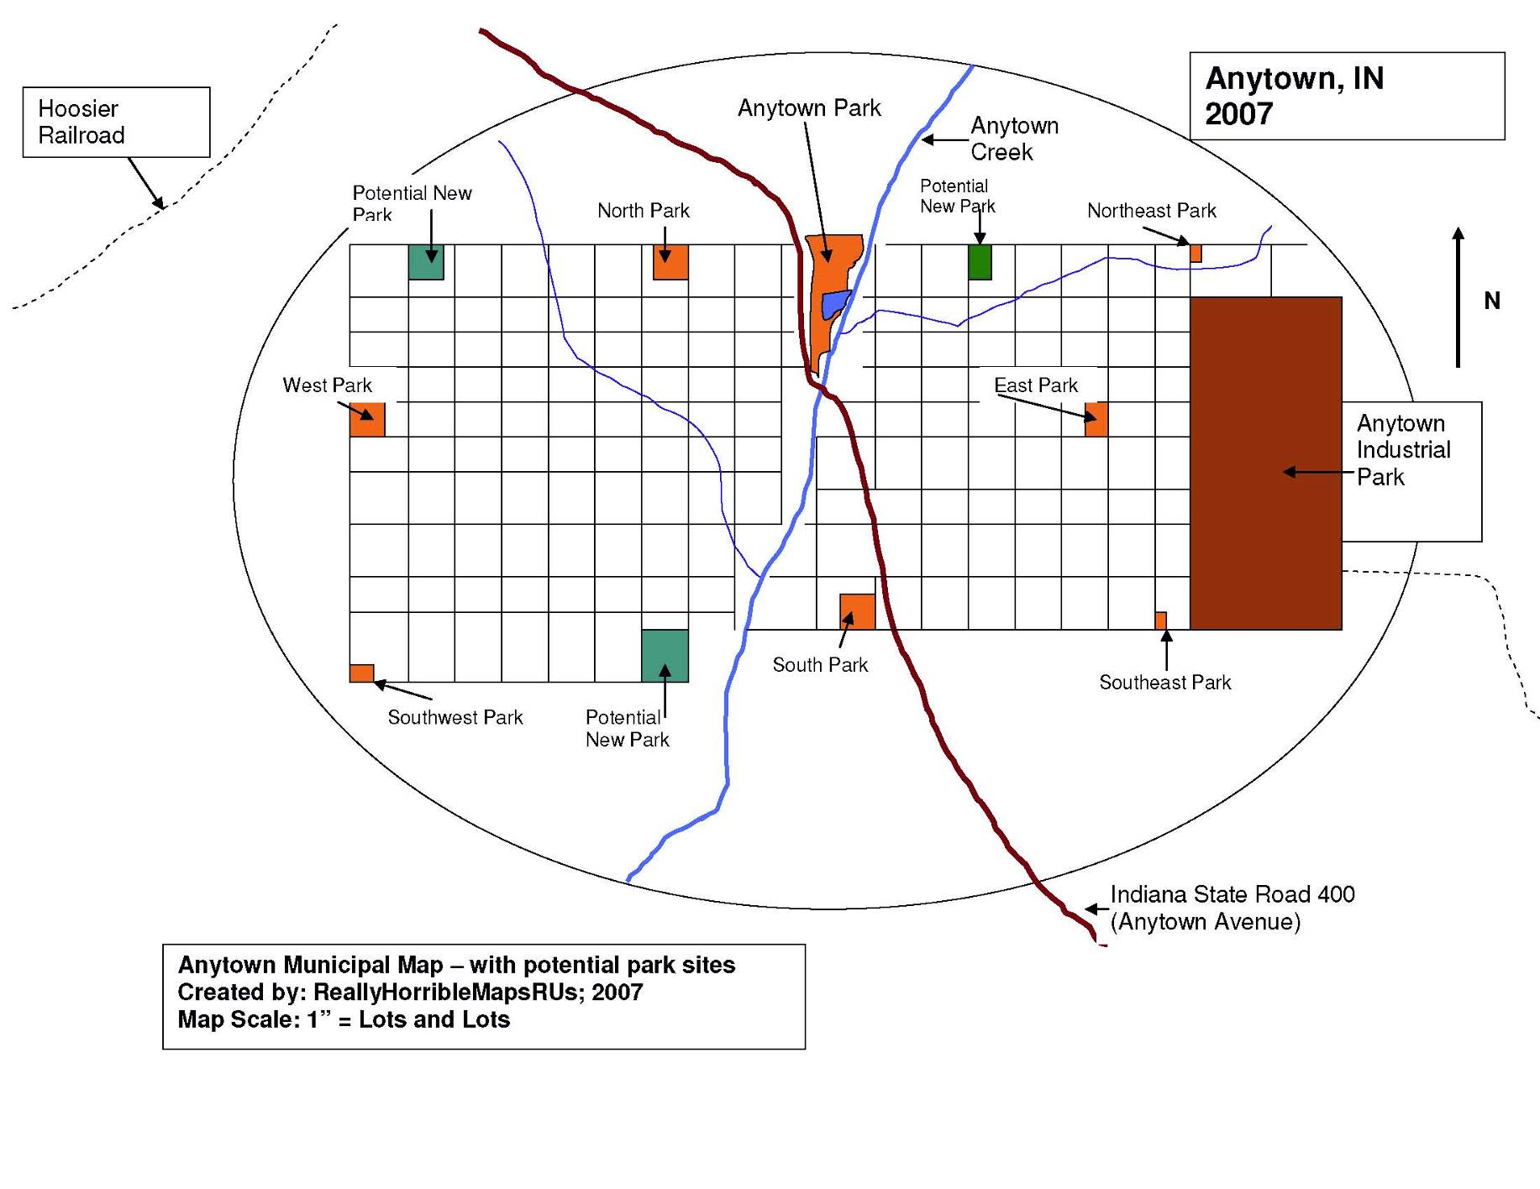
New Facilities Location Map

Priorities and Action Schedule
Setting the priorities for this plan was difficult, as financial constraints are the deciding factor for almost all new development or land acquisition for the Anytown Parks. Capital improvements have been almost non-existent for the last 20+ years in Anytown’s parks, except for lands donated or bequeathed to the city.

Transition into the New Plan
During the transition into the new planning period, the APRD will concentrate on fundraising of all types, with an eye toward increasing the current Anytown Park Fund under the Anytown Community Foundation to a self-sustaining or actively growing level. The duration of this transition period is 14 months, from now until one year into the planning period.

Potential fundraising options during the transition period:
- Municipal bonds.
- Sales taxes.
- Development impact fees/land donation requirements.
- User and entrance fees.
- Creative partnerships (with private and public entities).
- Grants (federal, state, foundation, non-profit, etc.).
- Donations:
  - In-kind, service and products.
  - Bequests.
  - Tax write-offs.
  - Corporate donations.
- Naming rights.
- Product sales (hats, t-shirts, etc.).

Fundraising will be critical; each of the action plan elements depends on having available funds to create it. Citizens of Anytown have provided input into what they want from parks and recreation for the next five years and now it is time to figure out a way to pay for it. One important consideration of the fundraising process is the old truism: “It takes money to make money.” This is particularly true of the grants application process. Most grants have some variety of “match,” which requires that the grant recipient provide a required percentage of the total cost of the grant funded project. The Land and Water Conservation Fund for example, provides a 50% reimbursement of the costs of approved projects; which means that Anytown must raise all of the money in advance for any projects that we wish to build under this grant.

Priorities for 2020 to 2025
- Fundraising drive/transition period (first 12 months of plan period).
- Creation of new programs for families, latchkey kids and adults, including programs in the evening and on weekends for second- and third-shift workers and their families.
- Addition of new accessible routes connecting all APRD parking areas, accessible restrooms, accessible shelters, and all other accessible park amenities.
- Removal of all unsafe play equipment; preparation of all play areas for new equipment.
- Installation of new, safe, accessible play equipment using volunteers and donated materials as much as possible.
- Development of new multi-purpose/ball fields as funds allow.
- Exploration of all available/willing seller potential park properties citywide.
- Purchase/donation/bequest of new parks lands citywide.
- Development of all newly acquired parks for multiple-uses.
- Creation of a signature amenity for the APRD.
  - Begin a public input process to determine what/where.
  - Potential ideas for a signature amenity include a skatepark, a splashpad/water feature, or indoor city pool.
  - Price of signature amenities will likely require special fundraising.

APRD System-wide Action Schedule
Budget Year | Priority Item | Lead Entity | Potential Cost | Potential Funding Source
2020+ | Fundraising transition  period | Friends of  Anytown Parks; Anytown Park  Board | Estimated cost of  fundraising varies; at  least $5,000 to  $10,000 for advertising,  promotions, staffing, etc. | Donations from community,  Board, local businesses;  grants; bequests;  Lilly Foundation match?
2020+ | Exploration-available  properties citywide | Anytown Park  Board | Cost can be included  somewhat with  fundraising;  no more than $5,000 | APRD budget; in-kind  donations of time/expertise
2021 | Creation of new  programs; latchkey  kids,adults, etc. | APRD  Recreation  Director | Varies based on  attendance,  type of program, fees  charged etc. Approx.  $15,000/yr. | APRD budget;  fees/donations as needed
2020-2021 | Remove current play  equipment;  preparation of play  area for new  equipment | APRD Park  Superintendent; Maintenance  Supervisor | Sell all metal equipment  for scrap; use proceeds  to pay for follow-up  costs of removal;  final costs approx.  $10,000 | APRD Budget; in-kind or  service donations from  local building contractors?
2021-2022 | Installation of new,  accessible play  equipment using  volunteers and  donated materials  as much as  possible | APRD  Maintenance  Supervisor;  Park  Superintendent | Depends on source of  equipment, potential for  volunteer installation,  size of equipment, etc.  Costs as high as  $350,000 for two or  three medium-sized  structures on accessible  surfaces | Anytown Park Fund; grants;  donations and in-kind;  bequests; APRD Budget.
2021-2022 | Develop new  multi-purpose/ball fields  (2-3 fields?) | APRD Park  Superintendent; Maintenance  Supervisor | Costs depend on  number of fields and  project complexity;  approximately $100,000 | Anytown Park Fund; grants,  donations, etc.
2022-2023 | Purchase/donation/  bequest new parks  lands citywide.  Target acres? | Anytown Park  Board;  Friends of  Anytown Parks; Park Staff | Costs depend on  number of plots, willing  sellers, etc. Costs could  range from $100,000 to $1,000,000 | Anytown Park Fund;  donations; bequests
2023-2026 | Development of all  newly acquired parks  for multiple-uses | APRD Park  Superintendent; Maintenance  Supervisor | Costs depend on  Number to develop &  amenities costs could  range from $500,000 to  $1,000,000 | Anytown Park Fund; grants;  donations and in-kind;  bequests; etc.
2023-2026 | Signature amenities  for larger parks,  such as a splashpad  or skatepark | Anytown Park  Board,  Friends of  Anytown Parks; Park  Superintendent | Costs depend on size/  complexity of design of  amenities; could range  from $500,000 to  $1,000,000 | Anytown Park Fund; grants;  donations and in-kind;  bequests; etc.

Appendices

Anytown Regional Map
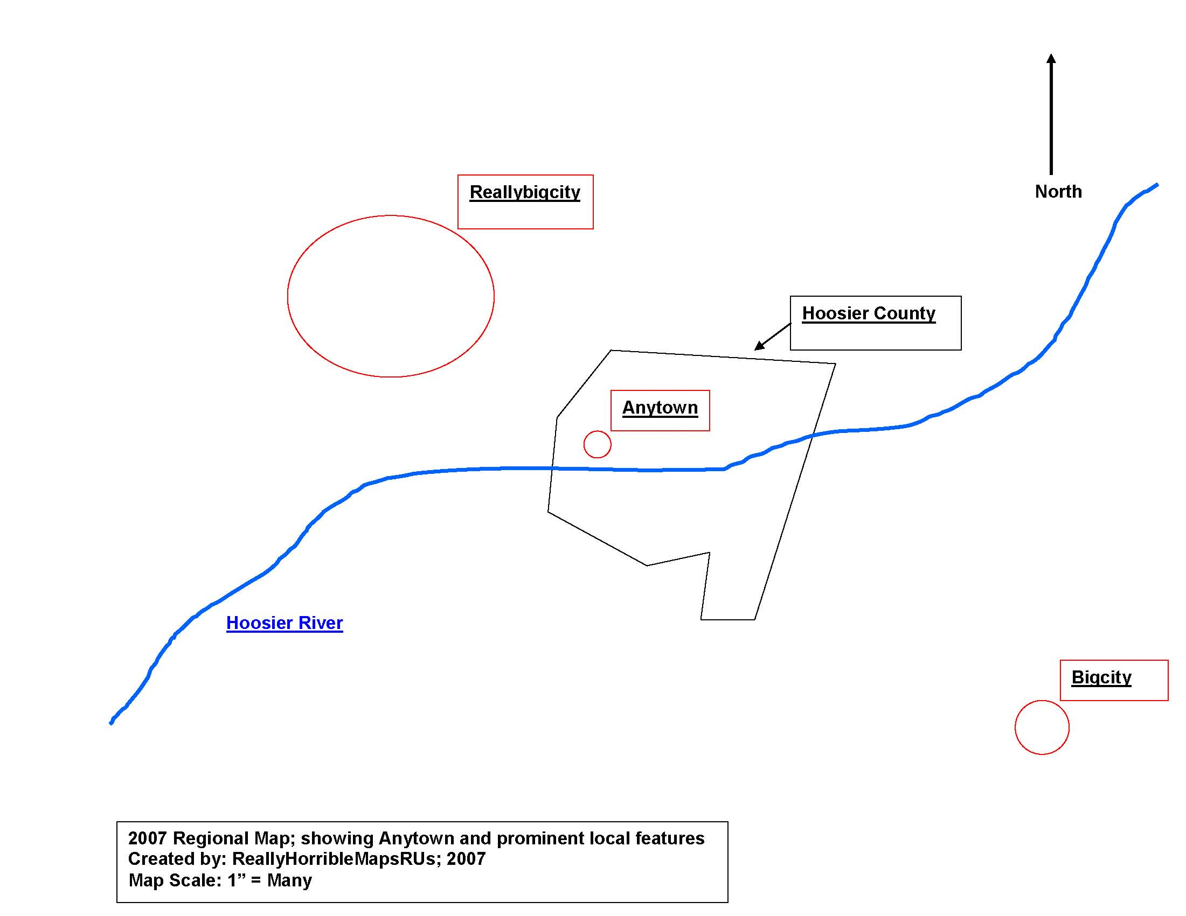
Interstate 100

SWOT (Strengths, Weaknesses, Opportunities and Threats) Analysis
Analysis made by APRD staff on Nov. 1, 2020

INTERNAL FACTORS
Strengths:
- Small, tightly-focused department with only eight parks to maintain/operate.
- Enthusiastic friends group and volunteer base to draw help from.
- Three professional, degreed/trained full-time park staff.
- Dedicated park board with long-serving members who truly love the APRD.
- Heavily-used park system, with popular programs and services.

Weaknesses:
- Ongoing budget cuts.
- Political and personal infighting between park board and city council (Council has threatened to eliminate the board).
- Lack of accessible routes, play features and playgrounds AND poor playground safety.
- Only 48 acres of public outdoor recreation land for a population of almost 19,000.

EXTERNAL FACTORS
Opportunities:
- Park system could use 332 more park acres to meet IDNR Level of Service recommendations (20 Acres/1,000 people recommended; or 380 acres, total for Anytown).
- Anytown still has some undeveloped open space within the city limits; some of this space is wooded, some is along Anytown Creek, and even some small prairie remnants.
- The Anytown Park Fund at the Anytown Community Foundation now has over $35,000 in it; could be used as grant match or to fund desperately needed facility upgrades.
- Anytown’s School District has offered to partner with APRD to create an official joint use agreement to share outdoor recreation facilities and programs, as well as programming opportunities and maintenance sharing.

Threats:
- Recently elected city council persons had campaigned on the promise to “shrink Anytown government spending and taxes at all costs,” beginning with the schools and parks.
- A brand new YMCA was just built next door to the aging and small Anytown Community Center building in Anytown Park.
- Opioid use in the greater Anytown area is skyrocketing, and Hoosier County has been forced to start a needle-exchange program just to attempt to stop the spread of HIV and other blood-borne pathogens.
- Hoosier County has been recognized as one of the most obese counties in Indiana by the Indiana State Dept. of Health.

BRAINSTORMING AND ANALYSIS
Ideas from the SWOT:
- Use community economic development and population/business attraction as levers to convince the tax-aversive new city council members that expanding the park system carefully over time is an investment in the city, not a waste of taxpayer money; use the Parks Fund as a springboard, and grant match.
- Seek land donations from willing donors for park expansions, especially of undeveloped land in the more “natural” areas of the city.
- Continue to leverage volunteer and friends group work to improve maintenance and safety of park features when possible.
- Consider cooperative efforts between the APRD and the Anytown Schools (joint-use agreement), and the Hoosier County Health Department (anti-drug programs, DARE, obesity programs, wellness programs, etc.)
- Consider expanding programs in APRD parks that emphasize the sports and activities that the YMCA does not offer (such as soccer, disc golf, fishing, and Tai Chi).

Community Benchmarking: Anytown; Schmoburg; and Other City, IN

Community: | Anytown, IN | Schmoburg, IN | Other City, IN
Population | 18,500 | 14,799 | 20,007
Median household Income | $41,000 | $52,000 | $39,000
% population growth since last Census | -2.5% | -3.7% | 4.8%
Number of Parks | 8 | 5 | 10
Total Acres of Public Park Land | 48 | 20 | 65
Number of Full-time employees | 3 | 0 (Parks maintained by streets dept.) | 6
Total yearly park budget | $142,000 | $50,000 | $250,000
Number of softball fields | 2 | 2 | 4 (set up as a “tournament cloverleaf”)

If you divide each community’s yearly park budget by their population, you get the yearly park expenditure per resident; a measure that allows you to compare how much financial support each community affords their parks: Other City spends $12.49 per resident, Anytown spends $7.67 per resident, while Schmoburg spends the least, at $3.37 per resident. Cross-comparing the communities becomes simple once the data is arranged like this. Anytown can now determine it is seeing good growth, and good median income, while somewhat behind in acreage, budget and softball fields when compared to Other City. Schmoburg is wealthier than the other two communities, but their declining population is a red flag that the community may not be investing that wealth in its future.

Accessibility Compliance Sign-Off Sheet

ASSURANCE OF ACCESSIBILITY COMPLIANCE WITH:
ARCHITECTURAL BARRIERS ACT of 1968 (As Amended);
SECTION 504 OF THE REHABILITATION ACT OF 1973 (As Amended);
AND TITLE II OF THE AMERICANS WITH DISABILITIES ACT OF 1990 (As Amended)

The ________________________________ (Applicant) has read the guidelines for compliance with the Architectural Barriers Act of 1968 (As Amended); Section 504 of the Rehabilitation Act of 1973 (As Amended); and Title II of the Americans with Disabilities Act of 1990 (As Amended) and will comply with the applicable requirements of these Acts.

SIGNATURE _____________________________
APPLICANT PRESIDENT

_____________________________
(President’s printed name)

SIGNATURE _____________________________

_____________________________
(Secretary’s printed name)

DATE_________________________

Board Resolution Adopting Plan
WHEREAS, the Anytown Park and Recreation Board is aware of the parks and
recreation needs of the residents of Anytown Indiana, and
WHEREAS, the Board realizes the importance of sound planning in order to meet the needs of its citizens,
NOW, THEREFORE, BE IT RESOLVED THAT THE ANYTOWN PARK AND
RECREATION BOARD, by unanimous declaration, does adopt the Anytown 5-year Comprehensive Park and Recreation Master Plan as its official plan for the next five years, for the growth and development of parks and recreational opportunities in Anytown .
Passed and signed this 20th day of February , 20__ .
ATTEST:

JANE DOE
President

Whose That
Town Attorney

 | Anytown Parks and Recreation Department  5555 Anytown Avenue  Anytown, IN 44444  (555) 555-1212 | 2020 APRD Public Survey

Please take a moment to help us improve your experiences in the Anytown Parks. When you’re done, please mail the questionnaire back using the self-addressed stamped envelope provided or bring it by City Hall or the Parks Office. The results of this survey will be added to the information being gathered for the 2020-2025 APRD 5-year Parks and Recreation Master Plan, and will help guide our decision making for the next five years.

All results gathered in this survey will be anonymous and all information is completely confidential. No information from these surveys will be used for any purpose other than park planning.

Park Use
How often do you use the Anytown Parks?  - Every day  - 4 or 5 times a week  - 3 or fewer times a week  - Once or twice a month  - Once or twice a year  - Never | How would you rate our parks?  - Consistent high quality  - Generally good  - Quality varies from park to park  - Poor quality
What do you typically do in the Parks?  - Use playgrounds  - Walk/jog/run  - Go fishing  - Relax  - Use sports fields  - Picnicking  - Ice skating  - Other__________________________ | Please select the people that you most often  use the park with:  - Family/children/grandchildren  - Friends  - Varies on each visit  - Just myself

Programs and Activities
How often do you use our programs or  activities?  - Every day  - 4 or 5 times a week  - 3 or fewer times a week  - Once or twice a month  - Once or twice a year  - Never | If you attend any of our programs, who do you  most often attend programs with?  - Family/children/grandchildren  - Friends  - Varies on each visit  - Just myself
How would you rate our programs or  activities?  - Consistent high quality  - Generally good  - Quality varies from program to  program  - Poor quality | Were the programs fun and well organized?  - Yes  - A little  - No

Participation
Is there anything that prevents or restricts  your use of the parks?  - Yes: if so, what? ______________________  - No  - Don’t use parks | Do any of these physical barriers restrict or  prevent your using the parks or programs?  - Physical access to the park or its  equipment  - Lack of accessible parking  - Parks too far away  - Other ____________________________________
What is the single most important thing  that prevents you from using the parks  or programs more?  - Lack of time  - Poor health/mobility  - Can’t afford the programs  - Lack of interest/don’t want to  - Other _____________________________ | I would like to see the APRD add the following  things (check all that apply):  - More accessible play equipment  - More walking trails/paths  - More benches/shelters/gathering areas  - More youth programs/activities?  What?__________  - More adult programs/activities?  What? __________  - New, large amenity: such as a  Splashpark, pool or skatepark

Park Funding
Would you like Anytown to invest more  money in the parks?  - Yes  - Maybe  - Depends on the investment  - No  - Don’t use parks | After first applying for all available grants and donations, how would you like Anytown to pay  for new amenities in the parks?  - Use existing budget  - Municipal Bonds  - New taxes/fees  - All the above
Are you willing to pay new taxes or  user fees to help pay for improvements  in the Anytown parks?  - Yes  - Maybe  - Depends on the improvements  - No | Are you willing to pay for improvements in the  Anytown parks using any of the following  methods? (check all that apply)  - Yes, small increase in program fees  - Yes, small increase in shelter reservation cost  - Yes, small yearly city park user tax  - No, can’t afford to pay anything for parks  - No, unwilling to pay anything for parks

If I could change one thing about the Anytown Parks, it would be: (please write in your answer)
________________________________________________________________________________________________________________________________
About You (Optional)
What is your approximate age?  - Under 18  - 19 - 25  - 26 - 35  - 36 – 45  - 46 – 55  - 56 – 65  - Over 65 | What is your gender?  - Male  - Female
What is your living arrangement?  - Single  - Divorced  - Widowed  - Married  - Domestic partner/significant other  - Roommate | What is the number of children living in your  household?  - None  - One child  - Two to three children  - Four or more children  What are their ages? ___________________________
What is your employment status?  - Unemployed  - Retired  - Employed part-time  - Employed full-time | What is your approximate household income?  - Under $20,000/year  - $20,001 to $40,000  - $40,001 to $60,000  - $60,001 to 80,000  - Over $80,000/year  - No answer
If you are employed, what shift do you  normally work?  - Days  - 2nd/early evening  - 3rd/late evening/graveyard  - Rotating/swing  - Other _______________________________ | Do you and your household:  - Rent your home?  - Own your home?  - Lease a condo/apartment?  - Live with others/relatives?  - Other? ______________________________

Thank you for your participation!

Newspaper notices, articles, sign-in sheets and meeting info

Newspaper articles
Anytown Reporter; “Parks Want Your Opinion!”; Sept. 5, 2020 (copy of article included here).
Anytown Reporter; “Park Survey Coming Soon”; Oct. 15, 2020 (copy of article included here).

Newspaper meeting notices
Anytown Reporter; “Community Meetings and Notices”; Sept. 10, 2020 (copy of notice included here).
Anytown Reporter; “Community Meetings and Notices”; Oct. 24, 2020 (copy of notice included here).

Sign-in sheets and agendas for meetings (by date)
Sign-in sheet for Sept. 15 meeting (copy of sign-in sheet included here).
Sign-in sheet for Oct. 27 meeting (copy of sign-in sheet included here).

Text of free cable TV info spot/PSA
- Public Service Announcement: run on local cable information channel “Community Calendar” ticker 25 times daily for 1 week prior to each public meeting. “Make your voice heard! The Anytown Parks Department wants to know what you want for the future of YOUR parks – facilities, locations, programs. You name it we hear it! Attend the Anytown Parks Department Public Meeting on ….. at the (Time, Date, Location)”

Text of free radio info spot/PSA
- Public Service Announcement runs on local AM/FM station “Anytown Hits – WWWW FM 109.9” four times daily during morning and evening drive times. “Hi! I’m Mayor Taylor Tarry, and the Anytown Parks and Recreation Department needs your feedback to this question! What can we do to improve YOUR park? Please come to the Anytown Parks Department Public Meeting at the (Time, Date, Location). We want to know what you think!”

Text of insert for city utility bills
- “Help the Anytown Parks Department improve YOUR parks! We need your input into the Anytown 5-year Parks and Recreation Master Plan. Please attend the public meeting at (Time, Date, Location) to share your ideas, opinions and concerns. We want to hear from you!” 3x5 brightly colored paper insert into city utility bill envelope.

