Selected Abstracts and Biographies

Oral Presentations

19th Annual
Surface Mined Land Reclamation
Technology Transfer Seminar

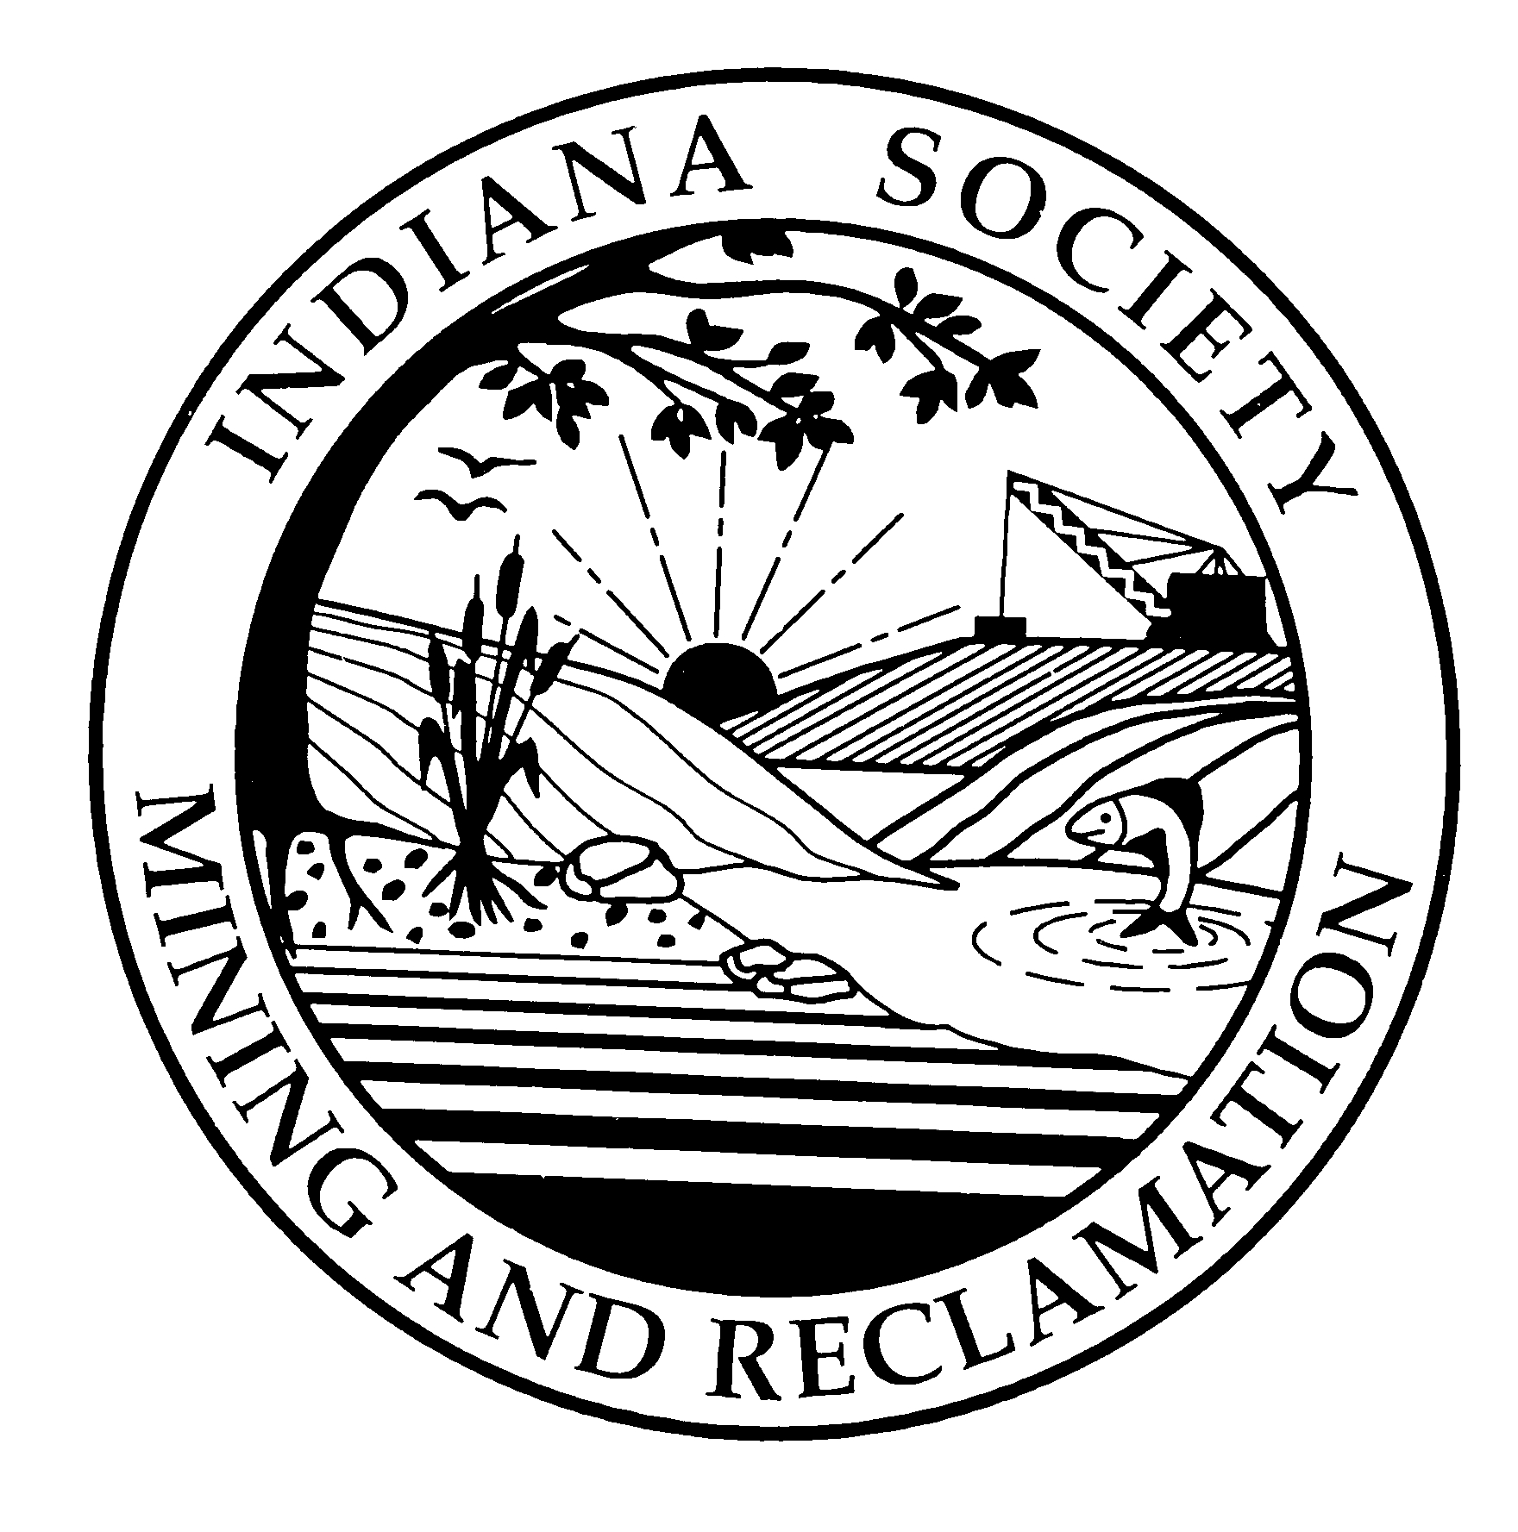

Indiana Society of Mining and Reclamation
December 5 & 6, 2005

CAD for Surface Mining Workshop

This workshop is intended to provide the student with an overview of various Autodesk and Carlson software products that will enhance their productivity. The workshop will cover new features in AutoCAD 2006. Detailed examples of how to use Autodesk Map and Autodesk Raster design will be provided for many everyday design needs such as; Querying Maps, Drawing Cleanup, Coordinate Transformation, Rubber-Sheeting, Digitizing, and Rectifying Images. There will be an overview of SurvCADD with an opportunity to ask questions on specific modules.

Passive Treatment of Acid Mine Drainage Workshop

Paul T. Behum, Office of Surface Mining
Tracy Branam, Indiana Geological Survey
Greg Bright, Commonwealth Biomonitoring Inc.

This course is intended to provide the student with an overview of the geochemistry and technology of modern passive treatment systems used to treat acid mine drainage. Several mini-exercises will be used to allow small student groups with to develop hands-on experience. The geochemistry discussion will include AMD formation, acidity vs. pH, pollutant metal chemistry (iron, aluminum, manganese) and the chemistry of carbonate systems. Before a treatment system is designed the AMD discharge must be characterized. Methods and techniques of baseline water data collection will be discussed which will include both water quality and quality assessments. The passive treatment technology discussion will include both treatment systems required for net-acid and net alkaline water. For net-acid treatment systems anoxic limestone drains (ALD), vertical flow ponds (VFP), anaerobic bioreactors & anaerobic wetlands will be included in the presentation. The net alkaline water presentation will include iron oxidation principles and biotic aerobic wetland and settling basin design. For each system: purpose and description, theory of operation, site requirements, design & engineering, and maintenance will be discussed.

Indiana Society of Mining And Reclamation
2005 Technology Transfer Seminar

Speaker Information

Presenter: Robert Dunker

Presenter’s Title: Agronomist

Association: University of Illinois

Address: 1102 South Goodwin Ave., Urbana, IL 61801

Telephone: (217) 244-5444 Email: r-dunker@uiuc.edu

Title of Presentation: A System to Evaluate Prime Farmland Reclamation Success Based on Spatial Soil Properties

Current Position: Superintendent, Crop Sciences Research & Education Center

Area of expertise: Agronomy and Soil Science

Biography:

Vita
Robert E. Dunker Born:
Agronomist & Superintendent July 8, 1950
Crop Sciences Research & Education Center Hannibal, MO
Department of Crop Sciences
University of Illinois

Office Address: Home Address:
AW 101 Turner Hall 604 Dorset Circle
1102 So. Goodwin Ave. St. Joseph, IL 61873
Urbana, Illinois 61801
Tel: 217/244-5444 Tel: 217/469-9073
FAX: 217-333-9817

EDUCATION

B.S. 1972, University of Illinois; College of Agriculture
M.S. 1986, University of Illinois; Department of Agronomy

EMPLOYMENT RECORD:
1994-Present, Agronomist and Superintendent, Crop Sciences Research & Education Center, Department of Crop Sciences, University of Illinois.
1977- 1994, Agronomist and Technical Manager, Prime Farmland Reclamation Program, Department of Agronomy, University of Illinios.
1974-1977, Assistant-Associate Agronomist, International Soybean Program (INTSOY) University of Illinois.
1973-1974, Soil Scientist, Sangamon County Illinois, Springfield, Illinois.

ORGANIZATIONS:
American Society of Agronomy
Soil Science Society of America
Past-Technical Division Coordinator and Member of National Executive Committee, American Society for Surface Mining and Reclamation
Past-Chairman, Illinois Surface Mining Advisory Council (Appointed by Gov. Jim Thompson, Reappointed twice by Gov. Jim Edgar).
Past-Chairman, North Central Regional Committee on Drastically Disturbed Lands, (NCR-106), Cooperative State Research Service, U.S. Department of Agriculture

Research and Publications:

Co-authored and received grants in excess of $1,700,000 related to reclamation of mined lands.
Authored or co-authored over 20 publications on subjects associated with surface mine reclamation.
Chapter, “ Cropland Reclamation” In Reclamation of Drastically Disturbed Lands. Revised edition, ASA Monograph No. 41, 2000, American Society of Agronomy

Indiana Society of Mining And Reclamation
2005 Technology Transfer Seminar

Abstract Information

Speaker Name: Robert Dunker

Title of Presentation: A System to Evaluate Prime Farmland Reclamation Success Based on Spatial Soil Properties

Abstract

Since the passage of Public Law 95-87, the Surface Mining Control and Reclamation Act (SMCRA) in 1979, reclamation success on agricultural lands has been determined by long-term yield testing. This has required a long bond release period lasting five years or more. Needs have been voiced from landowners, mine operators, and regulators for methods to expedite the bond release process. The financial burdens of annual cropping and field maintenance by mine operators and monitoring by regulators are of major concern. Landowners need to have the land returned to their production operations instead of being locked in the bond release process for a decade or more. A soil property based formula could relieve these financial burdens and ensure the most efficient process to return the productive soil resource to the landowner. In addition, this method also will identify problem fields immediately after reclamation. Currently, some reclaimed fields undergo several years of yield testing before a problem becomes evident. Then, after further remediation, an additional period of testing is required.

Indiana Society of Mining And Reclamation
2005 Technology Transfer Seminar

Speaker Information

Presenter: ______Bradley Charles Lewis ______________________________

Presenter’s Title:______Director of Marketing & Sales ___________________

Association: _____ICG ADDCAR Systems, LLC________

Address:___P.O. Box 28 Rush, KY 41168-0028_______________________

Telephone: __606-928-7237__________ Email: blewis@addcarsystems.com

Title of Presentation: __ Developments in Highwall Mining Techniques _____

Current Position:________________

Previous Position:_________________________________________________________

Area of expertise: ____Global Coal Mining Industry________________

Biography:

Brad Lewis has 27 years experience in the coal mining industry. During this time he has had a complimentary blend of experiences in engineering, manufacturing, operations and consulting. He began his career as a union laborer at Consol’s Arkwright No.1 underground mine and has progressed to executive level positions with John T Boyd Company, Joy Mining Machinery and Hilti. He has working experiences in 12 coal producing countries and has lived abroad twice (England & Australia).

Brad has an undergraduate degree in mining engineering from West Virginia University and he is a registered professional engineer. He also has a Masters in Business Administration from the University of Pittsburgh. Brad also has underground mine foreman papers in West Virginia and Colorado.

Indiana Society of Mining And Reclamation
2005 Technology Transfer Seminar

Abstract Information

Speaker Name: _______Bradley Charles Lewis____________________

Title of Presentation: ____Developments in Highwall Mining Techniques____

Highwall mining began in the late 1980s. It is a hybrid of surface and underground mining methods that can be used to extract otherwise uneconomical reserves. This technology has matured competently. When deployed in the proper applications, it is one of the safest, lowest cost, environmentally friendly and most productive mining methods.

The key to success in highwall mining is ensuring the availability of highwall. This is best accomplished when a long term mine plan is created that matches and synchronizes the surface mining capabilities with the highwall system.

Numerous other factors influencing the success of highwall mining will also be presented.

Indiana Society of Mining And Reclamation
2005 Technology Transfer Seminar

Speaker Information

Presenter: ______Tracy Branam_____________________________________________

Presenter’s Title:___Research Scientist________________________________________

Association: _______Indiana Geological Survey _____________________________

Address:_______611 North Walnut Grove, Bloomington IN 47405__________________

Telephone: __812-855-2682______ Email: ___TBranam@indiana.edu_____________

Title of Presentation: __Passive Treatment of Acid Mine Drainage Workshop_________

Current Position:_____Research Scientist_________________________________

Previous Position:_________________________________________________________

Area of expertise: Geology / Geochemistry of acid mine drainage formation in Indiana,__
groundwater chemistry, abandoned mine reclamation, stable isotopes, geochemical modeling, coal ash, FGD - residue, and hydrology issues.

Biography:

Tracy Branam has a Masters degree in geology from Indiana University with formal training in the geochemistry of metal deposits. He has been a Research Scientist at the Indiana Geological Survey located in Bloomington, Indiana, for 17 years studying the geochemistry of acid-mine drainage formation in Indiana and methods for prevention and treatment.

BRANDON SEITZ BIO

Brandon Seitz was born and raised in rural Jackson County, west of Seymour. He was involved in many activities growing up including high school athletics, choir, band, and service organizations like Key Club and 4-H. He attended Seymour High School where he graduated in 1995.

After high school Brandon attended Purdue University and majored in History and Political Science. He received his Bachelors of Arts from the School of Liberal Arts in 1999. In the summer of 2000 Brandon was hired by the Indiana House of Representatives, Republican Caucus. During his time as a Legislative Assistant for the House, Brandon worked for nine different state representatives.

Besides handling constituent work and correspondence, Brandon also helped his representatives with committee work. Brandon covered many committees during his nearly four year stint with the House including: Roads and Transportation, Agriculture and Natural Resources, Environmental Policy, Commerce and Economic Development, and the Regulatory Flex committee. Through his work with committees, Brandon gained knowledge in energy policy and realized that energy would be a large part of his future with state government.

In June of 2004, Brandon left state government to become the Constituent Services Director for the Mitch Daniels for Governor Campaign. After election Lt. Governor Becky Skillman asked Brandon to join her staff as Policy Director in charge of Homeland Security, Telecommunications, and Energy policy. Recently, Brandon became the Director for the Lt. Governor’s Indiana Energy Group. The Energy Group’s primary responsibility is to manage federal funding from the United States Department of Energy and distribute these funds through various grant opportunities. Brandon also is leading the development of Indiana’s strategic plan on energy policy.

Indiana Society of Mining And Reclamation
2005 Technology Transfer Seminar

Speaker Information

Presenter: _____Clarence Zink_________________________

Presenter’s Title:__Product Specialist________________________

Association: ___________Atlas Copco BHMT Inc._______

Address:_________P. O. Box 531226, Grand Prairie, Texas 75053-1226_________

Telephone: ___972-337-9798__ Email: __clarence.zink@us.atlascopco.com

Title of Presentation: _____Drilling Practices for Rotary Tricone Bits_______

Current Position:_________Product Specialist

Previous Position:__Open Pit Mine Foreman

Area of expertise: _______Exploration and Blasthole Drilling______

Biography:

BA in Geology from Univ. of Montana, Missoula, Montana, USA. 1972 – 1977 oilfield drilling engineering applications. Began mining career in 1977. Have worked as Exploration Geologist for Copper; Mine Geologist in UG Uranium and Tungsten; Mine Operations Foreman and Leach Operations Foreman in Open Pit Gold. Drilling Engineer in mineral core and rotary exploration drilling. Joined Baker Hughes Mining Tools (bought by Atlas Copco in 2004) in 1993 as Manager of Field Engineering. Married, two children: son, Lance Corporal J. Zink, assigned F-18 squadron, U.S.M.C. Daughter lives in North Carolina with two granddaughters and one grandson.

Abstract Information

Speaker Name: _____Clarence Zink_____________________

Title of Presentation: ____Drilling Practices for Rotary Tricone Bits______

Explain drilling practices for rotary tricone drill bits:
- Drilling parameters
- Tool care
- Drilling problem troubleshooting
- Interpretation of dull bit condition
Indiana Society of Mining And Reclamation
2005 Technology Transfer Seminar

Speaker Information

Presenter: Dan Hause

Presenter’s Title: Chief Engineer

Affiliation: Indiana Department of Natural Resources, Division of Reclamation

Address: R.R. 2 Box 129

Telephone: (812) 665-2207 Email: dhause@reclamation.dnr.state.in.us

Title of Presentation: CAD for Surface Mining Workshop

Current Position: Chief Engineer

Biography:

Dan Hause, PE
Indiana Department of Natural Resources, Division of Reclamation; Chief Engineer AML Program; B.S., Electrical Engineering, University of Pittsburgh; has 11 years experience with the Indiana Division of Reclamation, 19 years experience as a mining engineer with two coal companies in Indiana, West Virginia and Kentucky. Instructor for AutoCAD, Autodesk Map, Autodesk Raster Design, and SurvCADD courses for the OSM TIPS training program.

Indiana Society of Mining And Reclamation
2005 Technology Transfer Seminar

Speaker Information

Presenter: Douglass F. Jacobs

Presenter’s Title: Assistant Professor

Association: Hardwood Tree Improvement and Regeneration Center, Department of Forestry and Natural Resources, Purdue University

Address: 715 West State St.; West Lafayette, IN 47907-2061

Telephone: 765-494-3608 Email: djacobs@purdue.edu

Title of Presentation: American chestnut as a future resource to enhance mine reclamation productivity
Current Position: Assistant Professor

Previous Position:_________________________________________________________

Area of expertise: Forest Regeneration

Biography:

Doug Jacobs is currently assistant professor of forest regeneration within the Hardwood Tree Improvement and Regeneration Center in the Department of Forestry and Natural Resources at Purdue University. His research currently focuses on nursery production, tree physiology, and silvicultural management of fine hardwood species in the Central Hardwood Region.

Prior to coming to Purdue, Dr. Jacobs studied regeneration issues in coniferous species, receiving an M.S. degree from the University of Georgia in 1998 and a PhD from Oregon State University in 2001.

Indiana Society of Mining And Reclamation
2005 Technology Transfer Seminar

Abstract Information

Speaker Name: Douglass F. Jacobs

Title of Presentation: American chestnut as a future resource to enhance mine reclamation productivity

Abstract: Mine reclamation sites can be difficult to reforest, and trees that successfully establish on these sites are often comprised of relatively undesirable species. American chestnut (Castanea dentata) once dominated the forests throughout much of the coal-producing region in Appalachia. However, the exotic fungus Cryphonectria parasitica was discovered in 1904 and within several decades, the blight killed nearly every tree throughout the range. A dedicated breeding program sponsored by The American Chestnut Foundation has made tremendous progress toward producing a blight-resistant variety of American chestnut by hybridizing with the blight-resistant Chinese chestnut (Castanea mollissima). It is expected that a blight-resistant hybrid chestnut tree (~94% American chestnut) will be available for reintroduction within the next decade, providing a new species option for reclamation programs. Due to continued presence of the fungus throughout eastern forests, few studies have examined American chestnut growth performance in plantations. However, a recent study on a blight-free site in Wisconsin reported exceptional growth capacity of chestnut relative to co-occurring hardwood species. Sufficient evidence also exists to suggest that American chestnut may tolerate many of the stressful physical and chemical soil characteristics typical of mine reclamation sites. Rapid growth, adaptability to a wide range of environmental conditions, good timber quality, and exceptional wildlife properties make American chestnut a highly desirable potential species for future reclamation programs.

Indiana Society of Mining And Reclamation
2005 Technology Transfer Seminar

Speaker Information

Presenter: ___Greg Bright_________________________________________________

Presenter’s Title:____Director of Biological Studies _______________________

Association: ___Commonwealth Biomonitoring Inc._____________________________

Address:____8061 Windham Lake Drive, Indianapolis IN 46214___________________

Telephone: _317-297-7713______ Email: __Water_quality@tcon.net______

Title of Presentation: __Passive Treatment of Acid Mine Drainage Workshop_________

Current Position:__Director of Biological Studies, Commonwealth Biomonitoring, Inc.

Previous Position:___Senior Environmental Manager, IDEM______________________

Indiana Society of Mining And Reclamation
2005 Technology Transfer Seminar

Speaker Information

Presenter: Harry Verakis

Presenter’s Title: Senior Project Mgr.

Association: MSHA Technical Support

Address: Industrial Park Road, Box 251, Bldg. 1

Telephone: 304-547-2082______ Email: verakis.harry@dol.gov__

Title of Presentation: Blasting Accidents and Blasting Safety ____________

Current Position: Senior Project Mgr.

Previous Position: Supervisory General Engineer_______________

Area of expertise: Technical issues on explosives & blasting and fires and explosions in mining
Biography: Harry Verakis is senior project manager in MSHA Technical Support. He has been Chief of several groups in Technical Support. He has published many papers and made presentations on blasting, explosives, fires and explosions, and regulations. He is a member of ISEE, NFPA, a certified mine safety professional and certified fire and explosion investigator.

Abstract Information

Speaker Name: Harry Verakis__________________________________

Title of Presentation: Blasting Accidents and Blasting Safety_________

Indiana Society of Mining And Reclamation
2005 Technology Transfer Seminar

Speaker Information

Presenter: John A. Rupp

Presenter’s Title: Assistant Director for Research

Association: Indiana Geological Survey

Address: 611 N. Walnut Grove, Bloomington, IN 47401

Telephone: 812 855-1323_________ Email: rupp@indiana.edu

Title of Presentation: Research on Geological Carbon Sequestration at
Indiana Geological Survey

Current Position: as above

Previous Position: Research Scientist in Subsurface Geology

Area of expertise: Energy resources and technology

Biography:

Indiana Society of Mining And Reclamation
2005 Technology Transfer Seminar

Abstract Information

Speaker Name: John A. Rupp

Title of Presentation: Research on Geological Carbon Sequestration at
Indiana Geological Survey

The Indiana Geological Survey (IGS) en engaged for the last five years in a series of investigations that are designed to evaluate the deep subsurface geological realm of the state and the region for the possibility of using this as a long term storage site for carbon dioxide. The concept of “carbon sequestration” is being considered as a greenhouse gas mitigating strategy. CO2 produced by humankind is implicated in the warming of the globe. If this CO2 could be captured and sequestered for the atmosphere, this effect could be moderated.

With sponsorship by the Department of Energy and the collaboration with many of the fossil energy producing and consuming industries and researchers at other universities, the IGS is evaluating the potential of using deep unminable coal seams, oil and gas reservoirs, organic shales, and saline reservoirs as sequestration sites for storing CO2. Recently, Phase 1 of the Regional Partnerships initial assessment of the potential has been completed. As Phase II begins, Indiana will be involved in two four year programs to drill and test a variety of reservoirs in the deep subsurface.

Indiana Society of Mining And Reclamation
2005 Technology Transfer Seminar

Speaker Information

Presenter: Martha Clark Mettler___________________________

Presenter’s Title: Watershed Planning Branch Chief, Office of Water Quality,

Association: IDEM_________________________________________

Address: 100 North Senate Ave – IGCN – Indianapolis, IN 46204________________

Telephone: 317-232-8402____________ Email: mclark@idem.IN.gov _____

Title of Presentation: How Office of Water Quality programs relate to mining and reclamation. ______________________________________________________

Current Position: Watershed Planning Branch Chief

Previous Position: Ground Water Section Chief ______________________________

Area of expertise: Water Resource policy and planning ___________________

Biography:
In 1991 received a Bachelor of Science degree in Public Affairs with a concentration in science and management from IU.
In 1994 received a Master of Planning degree in Environmental Planning from IU.
Began work with IDEM’s Office of Water Quality in 1995.

Indiana Society of Mining And Reclamation
2005 Technology Transfer Seminar

Speaker Information

Presenter: Kevin W. Garnett

Presenter’s Title: Mining Engineer

Affiliation: Office of Surface Mining, Mid Continent Region

Address: 501 Belle St., Room 216, Alton, IL 62002

Telephone: (618) 463-6463 ext. 127 Email: kgarnett@osmre.gov

Title of Presentation: CAD for Surface Mining Workshop

Current Position: Mining Engineer

Biography:

Kevin W. Garnett, PE
Mining Engineer with the Office of Surface Mining Reclamation and Enforcement (OSM), Mid-Continent Region, located in Alton, IL. He has been employed by OSM for 6 years. His work with OSM has included AML and Bond Forfeiture reclamation design, permit review; and teaching AutoCAD, Autodesk Map, Autodesk Raster Design, and SurvCADD courses for the TIPS training program. Kevin obtained a BS in Mining Engineering from the University of Missouri-Rolla in December, 1999.

Indiana Society of Mining And Reclamation
2005 Technology Transfer Seminar

Speaker Information

Presenter: _______LARRY SCHNEIDER________________________

Presenter’s Title:___PRESIDENT_______________________________

Association: _____DETONATION SAFETY ENGINEERING _______

Address:_________121 CHERRYWOOD DRIVE, NICHOLASVILLE KY 40356_

Telephone: __(859) 312-0625_______ Email: _Lschneider@insightbb.com

Title of Presentation: ______________________________________________________

Current Position:________________

Previous Position:_Division Director, Kentucky Division of Explosives and Blasting

Area of expertise: __ Blasting Safety, Vibrations and Damage, Regulations

Biography:

Master of Science, Physics Xavier University, Cincinnati, Ohio
Bachelor of Arts, Major in Physics, Minor in Mathematics
Thomas More College, Ft. Mitchell, Kentucky

President/Owner, Detonation Safety Engineering
Nicholasville, Kentucky, August, 2002 to present
Consulting company specializing in Blasting and Explosive related projects

Director, Division of Explosives and Blasting 1979-2002
Kentucky Department of Mines and Minerals
Responsible for the statewide enforcement of laws and regulations governing all aspects of explosives and blasting .

Explosives and Blasting Inspector/Instructor 1973 -1979
Kentucky Department of Mines and Minerals
Field position inspecting blasting operations for compliance with laws and regulations.

LICENSES & CERTIFICATES
Registered Professional Engineer in Kentucky
Kentucky General Blaster License

ASSOCIATIONS:
International Society of Explosives Engineers, Cleveland, Ohio
Served on Board of Directors from 1989 to 2004
Served two terms as President, 2000-2002

Tristate Chapter of Society of Explosive Engineers, Evansville, Indiana
Board member and Newsletter editor 1984 to present

Bluegrass Chapter of Society of Explosive Engineers, Lexington, Ky
Past board member and Secretary 1992- present

Kentucky Blasting Conference Associaton, Louisville, Kentucky
served as Secretary-Program Chairman from 1979 - 2001
currently serving as Executive Director 2002 –present

Abstract Information

Speaker Name: _______Larry Schneider____________

Title of Presentation: ___Blasting Accidents, Causes and Prevention______

The paper will explore some basic explosive safety ideas through a discussion of actual case histories of accidents. The leading causes of blasting injuries and fatalities will be illustrated through accident descriptions taken from official reports.

Actions that could have prevented these accidents and future accidents are listed and discussed. Emphasis is placed on the blaster’s responsibility to be alert to conditions on and around the blast site that could adversely impact safety.

Indiana Society of Mining And Reclamation
2005 Technology Transfer Seminar

Speaker Information

Presenter: Maria Mastalerz__________________________________________________
Presenter’s Title:_Dr. __________________________________________

Association: Indiana Geological Survey, Indiana University_______________________
Address: 611 North Walnut Grove, Bloomington, IN 47405-2208___________________

Telephone: 812-855-9416_________ Email: mmastale@indiana.edu_______

Title of Presentation: Origin of coalbed gas in Indiana; Insights from isotopic ratios_____

Current Position: Research Scientist/Coal Geologist ____________

Previous Position:_________________________________________________________

Area of expertise: coal geology, organic petrology, organic geochemistry____________

Biography:

Mastalerz’s area of expertise is coal geology, organic petrology and geochemistry. She hold M.S. degree (1981) in geology from Wroclaw University, Poland and Ph.D. degree (1988) in mining geology from Silesian Technical University, Poland. She was a postdoctoral fellow and a research associate at Department of Geological Sciences of the University of British Columbia, Vancouver from 1990 till 1994. She has been employed as a coal geologist at the Indiana Geological Survey since 1994. She is also a Graduate Faculty since 1996 and Adjunct Professor at the Department of Geological Sciences since 1999.

She has conducted research on coal of various ages, ranks (from lignite to anthracite), and geographic locations (Poland, Canada, Australia, New Zealand, and USA). Large part of her research is directed towards optimizing coal utilization through the understanding of coal properties and chemistry. Her research ranges from field scale characterization to molecular structure of organic matter. Other her interests include controls on coalbed methane potential and CO₂ sequestration.

Mastalerz is a co-editor of two books and author or co-author of about 100 full size publications in refereed journals. She is also an Associate Editor of International Journal of Coal Geology. She is a recipient of several national and international awards and these include Visiting Erskine Fellowship in the Department of Geological Sciences of the University of Canterbury in New Zealand in 2000, Gordon H. Wood, Jr., Memorial Award (Eastern Section of AAPG) in 2002 - for outstanding contribution to the understanding of coal geology, and Organic Petrology Award in 2004 – presented by International Committee for Coal and Organic Petrology - in recognition of outstanding contributions to organic petrology and leadership in promoting the development and applying innovative methodologies to the study of coal.

Indiana Society of Mining And Reclamation
2005 Technology Transfer Seminar

Abstract Information

Speaker Name: Maria Mastalerz_____________________________________________

Title of Presentation: Origin of coalbed gas in Indiana; Insights from isotopic ratios____

The coalbed gas potential in the Illinois Basin has been previously underestimated because of the low rank of coals and their low thermogenic gas potential. Our recent compositional and isotopic data suggest that, in addition to thermogenic gas, these coals contain a significant contribution of biogenic gas, making the Illinois Basin (i) an important coalbed methane target and (ii) a natural laboratory to study gas generation and its geological controls on a basin-wide scale. Multiple drill sites in the SE Illinois Basin (Pennsylvanian age) provided gas samples from five Pennsylvanian-age coal beds. We determined (i) ¹³C/¹²C ratios in hydrocarbons C₁ (=CH₄), C₂, C₃, i-C₄, n-C₄ and in CO₂ and (ii) D/H ratios in C₁. The coal beds range from 100 to 350m in depth and represent high volatile bituminous coal (R_{o} 0.54 to 0.75%).
The gases vary compositionally depending on coal maturity. For example, gas from 100m-deep Springfield coal from southwest Indiana having an R_{o} of 0.56% contains 98% C₁ and only trace amounts of C₂₊, whereas the age-corresponding more mature coal bed in western Kentucky at a depth of 350m and R_{o} of 0.75% yields gas having 5.6% C₂ and 1.3% C₃. These Indiana and Kentucky coalbed gases also differ isotopically having δ¹³C_{CH4} = -63.1‰ and -49.5, and δ¹³C_{CO2} = 2.8‰ and -20.6‰, respectively (Fig. 1). Indiana coals are at or slightly above the threshold for thermogenic gas generation (R_{o} ~ 0.55%), the gases are usually of mixed thermogenic and biogenic origin, with the biogenic component being formed by a microbial CO₂ reduction pathway. Using Katz’s approach, we estimate that the biogenic component is negligible in the highest-rank Springfield coal in western Kentucky. For lower-rank Springfield coal in Indiana and eastern Illinois, the contribution of biogenic gas ranges from 57% to 100%. Proportions of thermogenic versus biogenic gas for other coal beds show similar variability.
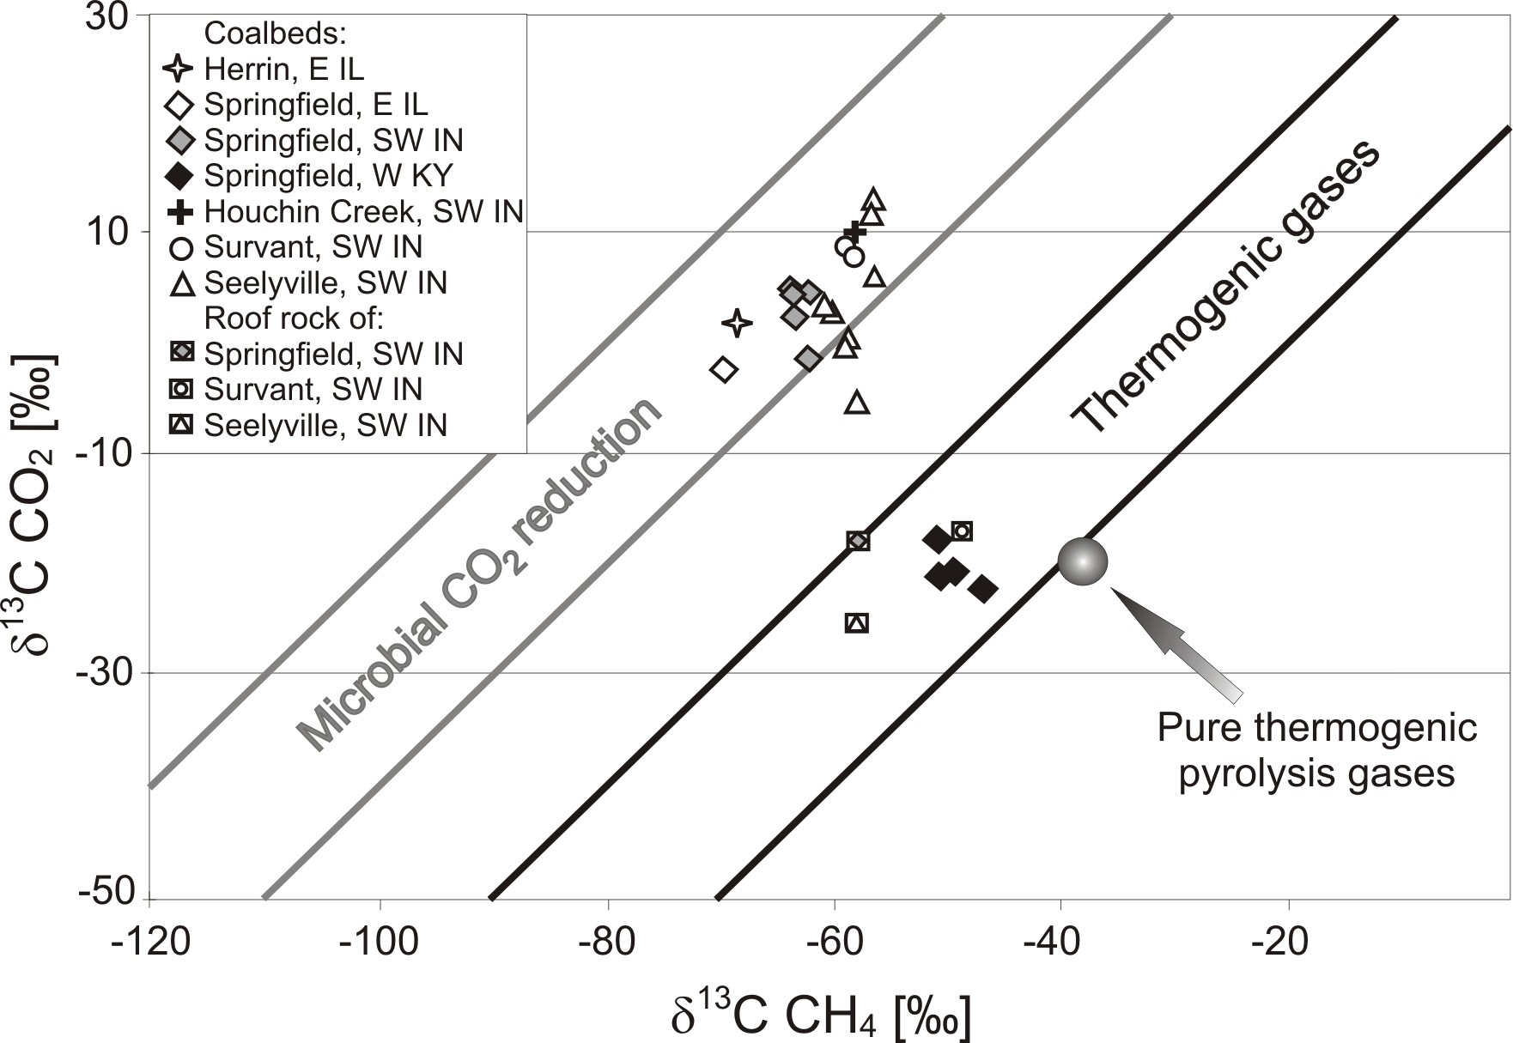

Fig. 1. Coalbed gas carbon isotopic data from the SE Illinois Basin, after Smith and Pallasser (1996).
Indiana Society of Mining And Reclamation
2005 Technology Transfer Seminar

Speaker Information

Presenter: _Mark Stacy_______________________________________________

Presenter’s Title: Environmental Specialist

Association: _IDNR – Division of Reclamation_____________________________

Address:_RR 2 Box 129, Jasonville, IN 47438___________________________

Telephone: _812-665-2207____ Email: __mstacy@reclamation.dnr.state.in.us

Title of Presentation: The Use of Wildlife Enhancement Techniques by the Indiana AML Program

Current Position:___Same as above

Previous Position:____N/A________________________________________________

Area of expertise: _NEPA and environmental permitting, compliance and enhancement

Biography: Mark is responsible for all aspects of environmental review for each reclamation project completed by the Indiana Abandoned Mine Lands Program including the NEPA review process. He is also responsible for ensuring compliance with all state and federal environmental rules and regulations including environmental permits such as NPDES, CWA Sections 401 and 404, Construction in a Floodway and endangered species reviews. He was instrumental in the development of the Indiana Bat Gating Program that has protected numerous bat roosting sites and continues to survey mine openings for bat usage. Mark is a strong advocate of the development of wetlands for both wildlife habitat and passive treatment of acid mine drainage. And he works closely with the Project Engineer and Project Manager during both the design and construction phases of each project to incorporate environmental enhancement techniques to create biologically diverse and self-sustaining reclamation projects.

Indiana Society of Mining And Reclamation
2005 Technology Transfer Seminar

Abstract Information

Speaker Name: ____Mark Stacy_____________________________________________

Title of Presentation: __The Use of Wildlife Enhancement Techniques by the Indiana AML Program

The main goal of the Indiana Abandoned Mine Lands (AML) Program is to eliminate the public health and safety hazards and environmentally degrading conditions resulting from past coal mining activities. Obviously, by simply reclaiming a site, we can have major improvements in environmental health and wildlife habitat. For example, covering and revegetating a coal refuse pile, slurry pond or acidic impoundment will have immediate positive impacts on the local wildlife. However, the manner in which the site is reclaimed can have a tremendous influence on the quality of wildlife habitat that is created. In reality, there are many simple techniques that can be used to dramatically improve the quality of wildlife habitat on these reclamation projects. This presentation will demonstrate some of the wildlife enhancement techniques that are being used by the Indiana AML Program.

Indiana Society of Mining And Reclamation
2005 Technology Transfer Seminar

Speaker Information

Presenter: ____Mike Kelly__________________________________________

Presenter’s Title:____Senior Safety Manager________________________

Association: _____Dyno Nobel North America_______________________________

Address:___2650 Decker Lake Blvd. Suite 300 Salt Lake City, UT 84119____

Telephone: __801-364-4800 ext.6412 Email: __mike.kelly@am.dynonobel.com_

Title of Presentation: ___Take 5! A Simple Thing_______________________

Current Position:____32 years in current position

Previous Position:_____na_________________________________________________

Area of expertise: ____ Occupational Safety and Health___________________

Biography: Michael E. Kelly

Mike Kelly is Senior Safety Manager for Dyno Nobel Inc., the largest maker of commercial explosives in North America. He earned a Bachelors of Science degree from the University Of Utah in 1972 and a Masters Degree in Health Science Education from Brigham Young University in 1976. He began his career in Safety in 1973 with IRECO Chemicals, Dyno’s predecessor, and has worked for 32 years in a variety of safety disciplines including safety program administration, regulatory compliance, incident investigation, and safety auditing and hazards assessment. He is a Professional Member of the Society of Safety Engineers and a member of the International Society of Explosives Engineers.

Mike has served as Chairperson of the Health and Safety Committee of the Institute of Makers of Explosives, a Washington DC based safety organization for the Explosive industry. As part of his responsibilities with the IME he has been directly involved in writing, and commenting on safety standards for explosives for Federal, State and Local regulatory agencies and entities. He has also worked as an independent safety consultant outside of the explosive industry.

Indiana Society of Mining And Reclamation
2005 Technology Transfer Seminar

Abstract Information

Speaker Name: __Michael E. Kelly_____________________________________

Title of Presentation: ___Take 5! A Simple Process That Results in Big Benefits___

Why is it that after making every effort to write and update procedures, inspect facilities, conduct investigation, hold periodic safety meetings, audit programs, and make every effort to insure regulatory compliance industries still can’t seem to prevent accidents? The answer is simple but the fix can be complicated. Human behavior. How do we as safety professionals or facility managers get the employee to care about their own safety? How do we get them to watch out for themselves and the other guys. Dyno Nobel thinks the answer is a simple little program called “Take 5!”.

Indiana Society of Mining And Reclamation
2005 Technology Transfer Seminar

Speaker Information

Presenter: Paul T. Behum

Presenter’s Title: Hydrologist

Affiliation: Office of Surface Mining, Mid Continent Regional Coordinating Center

Address: 501 Belle St., Room 216, Alton, IL 62002

Telephone: (618) 463-6463 ext. 127 Email: pbehum@osmre.gov

Title of Presentation: Passive Treatment of Acid Mine Drainage Workshop

Current Position: Hydrologist

Biography:

Paul T. Behum is a Hydrologist with the Office of Surface Mining Reclamation and Enforcement (OSM), Mid-Continent Regional Coordinating Center located in Alton, IL. He has been employed by OSM for 21 years. His work with OSM has included passive treatment reclamation design, hydrologic investigations, and performance bond estimation. Paul obtained a BS and MS in geology from the University of Pittsburgh and is currently a student in residence in the Environmental Resources and Policy Doctor of Philosophy program at Southern Illinois University at Carbondale.

Indiana Society of Mining And Reclamation
2005 Technology Transfer Seminar

Speaker Information

Presenter: _____Robin Mills Ridgway, Ph.D., P.E.____

Presenter’s Title: Purdue University Physical Facilities Environmental Regulatory Consultant

Association: _____________________________________________________________

Address: 550 Stadium Mall Drive, Civil Engineering Building B173, West Lafayette, IN 47907_

Telephone: _____765-496-6405__ Email: __rmridgway@purdue.edu_

Title of Presentation: _Mercury in Coal: Indiana Environmental Regulatory Implications

Current Position:_see above position title__

Previous Position:_________________________________________________________

Area of expertise: ________________________________________________________

Biography:
ROBIN MILLS RIDGWAY, Ph.D., is an environmental regulatory consultant and environmental engineer employed by Physical Facilities Radiological and Environmental Management/Utilities at Purdue University. She assists and advises the University with environmental compliance with state and federal regulations, including the Clean Air Act and the Clean Water Act. She also provides technical guidance and recommendations to the University's Wade Utility, which provides heating and cooling and approximately half of the electricity for Purdue’s West Lafayette, Indiana campus. She is a licensed professional engineer in Indiana. Dr. Ridgway earned her Ph.D. in environmental engineering from Purdue University.

Indiana Society of Mining And Reclamation
2005 Technology Transfer Seminar

Abstract Information

Speaker Name: _______Robin Mills Ridgway
Title of Presentation: ____ Mercury in Coal: Indiana Environmental Regulatory Implications

Abstract:

Reduction of mercury emissions to the air from coal fired power plants are the subject of both federal and state level environmental regulatory initiatives. The mercury and chlorine content of coal varies by deposit, seam, and within a seam. In developing a compliance strategy, a coal fired facility must not only understand its “back end” pollution control equipment options, but also the mercury and chlorine content of its incoming fuel. This presentation is a summary of information regarding mercury and chlorine content of coals (particularly Illinois basin coals) and how the content and variability may dictate control strategies under several possible environmental regulatory scenarios.

Indiana Society of Mining And Reclamation
2005 Technology Transfer Seminar

Speaker Information

Presenter: ____Dr. Ronald H. Carty________________________________________

Presenter’s Title:__________Director__________________________________

Association: _____Illinois Clean Coal Institute___________________________

Address:____5776 Coal Drive, Suite 200, Carterville, IL___________________

Telephone: ___618-985-3500______ Email: ___ronc@cos.siu.edu_____

Title of Presentation: ____The Illinois Clean Coal Research and Development Program__

Current Position:______Director of the Illinois Clean Coal Institute

Previous Position:____Assistant Director, Institute of Gas Technology________

Area of expertise: _Coal Gasification___________________________________

Biography:
Dr. Ronald H. Carty has over thirty years of experience in research and development and manages the Illinois Clean Coal Institute which he joined in 1997. His career in coal research began at the University of Kentucky where he received his Ph.D. in Chemical Engineering. There he joined the Institute for Mining and Minerals Research and helped to develop projects in multi-fuel and fluidized-bed combustion systems as well as production of hydrogen through thermochemical water-splitting.
Dr. Carty then joined the Institute of Gas Technology, and during his sixteen years of service he earned the position of Assistant Director. At IGT he directed programs for thermal gasification of biomass, coal liquefaction, coal tar upgrading, sulfur removal from coal char, and research on sulfur sorbents, as well as the development of an advanced mild gasification process for coal that produces solid and liquid co-products. He also managed research on mineral matter behavior in coal gasification, high-temperature gas cleaning, and direct-flux solar reactor applications.

Indiana Society of Mining And Reclamation
2005 Technology Transfer Seminar

Abstract Information

Speaker Name: ______Dr. Ronald H. Carty__________________________________

Title of Presentation: __The Illinois Clean Coal Research and Development Program__

Abstract

The Illinois Clean Coal Institute (ICCI) Coal Research and Development (R&D) Program is the technical component of the Office of Coal Development (OCD) of the Illinois Department of Commerce and Economic Opportunity (DCEO). OCD deals with developing and conducting the Illinois Coal R&D program. The ICCI, under the direction of DCEO/OCD, promotes the development and application of new and/or improved technologies that contribute to the economic and environmentally sound use of Illinois coal. This is accomplished using outside contractors to conduct R&D, evaluation studies and the development of concepts to assist producers and users of Illinois coal in an increasingly competitive marketplace, and to create new markets for Illinois coal.
Dr. Carty will discuss the operation of the ICCI including setting R&D goals, development of an annual request for proposals, selection of projects, and the current program.

